Phylogenetic Model for the Evolution of Carnivorous Plant Traps: Investigating the Origin of *Utricularia* Trap

Masafumi Obara

Te Kura Mātauranga Koiora | School of Biological Sciences

Waipapa Taumata Rau | The University of Auckland

*A thesis submitted in partial fulfilment of the requirements for the degree of Bachelor of Science Honours in Biological Sciences,*

*The University of Auckland, 2023*

# **Abstract**

Carnivorous plants are a unique group of plants that have evolved to capture and digest prey to supplement their nutrient intake. Although they have been the subject of fascination and study for almost 140 years after Darwin’s book *Insectivorous Plants*, the origin of carnivorous *Utricularia* plant traps has not been discussed in detail. The genus *Utricularia*, or bladderworts, is the most diverse genus of carnivorous plants and draws attention because of the very complex mechanism and tiny size of the bladder-like traps. The traps suck in prey in less than a millisecond, making this one of the fastest movements in the plant kingdom. In this research, we build a phylogenetic model for the evolution of carnivorous plant traps to test the “pitcher hypothesis” for the origin of the *Utricularia* trap. We assemble phylogenetic trees for carnivorous plant species to test our hypothesis with statistical model comparison: the fit of a model where *Utricularia* bladder traps are essentially miniaturised pitcher traps is compared to a null model where any trap type can evolve into any other.

The results suggested that among the ten phylogenetic models evaluated, the resM05 model, aligning with the pitcher hypothesis, emerged as the best-fitting model, as evidenced by its lowest AIC value and the highest AIC weight. Phylogenetic stochastic mapping under the resM05 model revealed a maximum transition rate from aerial to ground pitcher traps. This highlighted the central tendency of the estimated transition rates, emphasizing the evolutionary significance of the shift from aerial to ground pitcher traps in carnivorous plant evolution. Additionally, the equal-rates null model (resER) showed a maximum transition rate from ground to amphibious pitcher traps. The ancestral states inferred from the phylogenetic stochastic mapping further supported the resM05 model, indicating a common ancestor for ground sticky and aerial pitcher traps. In contrast, the resER model suggested a distinct ancestral state for ground sticky and aquatic pitcher traps.

This research significantly contributes to the understanding of carnivorous plant evolution by employing phylogenetic modeling and stochastic mapping analyses. The inferred ancestral states further elucidate the evolutionary relationships, supporting a common ancestor for ground and aerial pitcher traps under resM05, while resER suggests a different origin for ground sticky and aquatic pitcher traps. Overall, these findings contribute a nuanced perspective on the evolutionary pathways of carnivorous plant traps, advancing our knowledge of their diversification and adaptive strategies in response to ecological challenges.

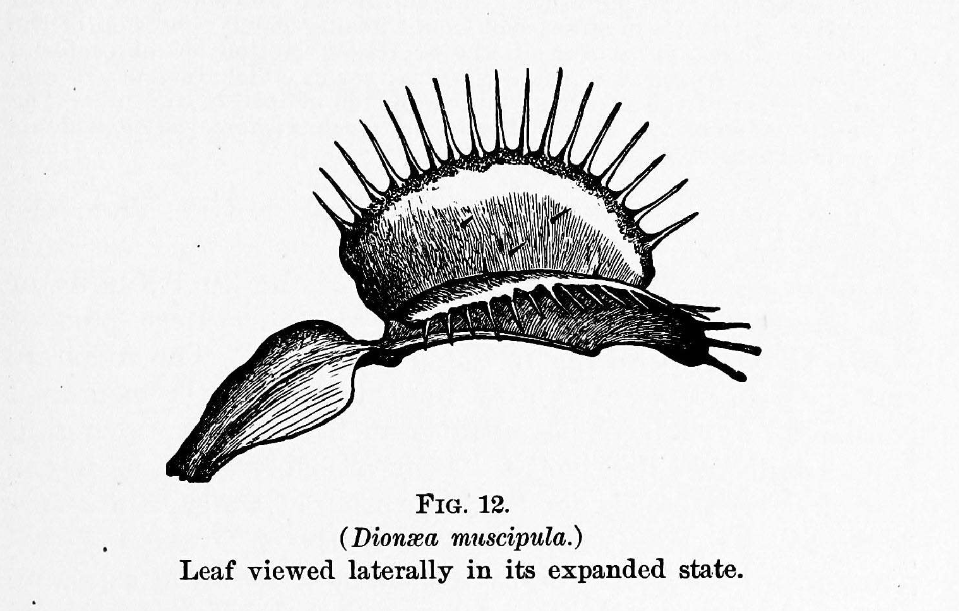

‘This plant, commonly called Venus' fly-trap, from the rapidity and force of its movements, is one of the most wonderful in the world.’

(Darwin, 1875)

# **Acknowledgements**

First and most, I would like to express my sincere gratitude to my supervisor, Dr. Nick Matzke, whose expertise in phylogeny and biogeography and unwavering support made this research possible. His guidance, from introducing the research to providing assistance in bioinformatics and computational analysis, has been invaluable. I appreciate his patience in helping me navigate R studio coding and answering my numerous questions. I am truly grateful for the opportunity he gave me to delve into my passion for evolution, phylogeny, and biogeography. Thank you so much, Nick, for your support, guidance, patience and encouragement throughout this thesis.

I extend my heartfelt thanks to my family for their enduring support. My parents, my mom and dad, have been instrumental in allowing me to pursue my studies overseas and supporting me throughout my university years. Their encouragement has been a driving force in my academic journey. To my sisters Erina and Yukina, I am immensely grateful for the unwavering pride and support extended to me throughout my educational journey overseas.

I would also like to acknowledge my best friend Sruti, whose unwavering emotional support has been a constant throughout my university years. Her encouragement and friendship have played a significant role in my academic and personal growth. To my other best friend Shayal, thank you so much for always listening to me throughout my university years.

Thank you to everyone who has been a part of this academic endeavour, contributing to its success in various ways.

**Table of Contents**

**Abstract** 2

**Acknowledgements** 4

**List of Figures** 7

**List of Tables** 8

**Chapter 1: General Introduction** 9

**1.1 Rationale of Study** 9

**1.2 An Introduction to Carnivorous Plant Trap Evolution** 9

**1.2.1 Plant Adaptations and Ecological Strategies** 9

**1.2.2 Carnivorous Plants: The Voracious Predator** 10

**1.2.2.1 Aerial and Ground Sticky Leaf Traps** 10

**1.2.2.2 Amphibious Snap Traps** 11

**1.2.2.3 Aquatic Snap Trap** 12

**1.2.2.4 Transitional Traps** 12

**1.2.2.5 Aerial and Ground Pitcher Traps** 13

**1.2.2.6 Amphibious Pitcher Traps** 14

**1.2.2.7 Aquatic PitcherTraps** 14

**1.2.3 Prior Attempt at Explaining the Origin of the *Utricularia* Trap** 16

**1.2.4 The Pitcher Hypothesis** 17

**Chapter 2: Statistical Model Comparison to Test Pitcher Hypothesis for the Origin of the *Utricularia* Trap** 19

**2.1 Introduction** 19

**2.2 Methods** 22

**2.2.1 Data Collection: Phylogenetic Trees** 22

**2.2.2 Data Collection: Carnivorous Plant Trap Types** 25

**2.2.3 Assembling Trees** 27

**2.2.4 Transition Rate Matrices** 28

**2.2.5 Model Selection by BioGeoBEARS** 31

**2.2.6 Ancestral State Estimation by BioGeoBEARS** 32

**2.3 Results** 33

**2.3.1 Model Selection** 33

**2.3.2 Phylogenetic Stochastic Mapping** 34

**2.4 Discussion** 36

**2.4.1 Summary of Model Selection** 36

**2.4.2 Summary of Phylogenetic Stochastic Mapping** 39

**2.4.3 Concluding Remarks** 40

**Chapter 3: General Discussion** 42

**3.1 Thesis Aim** 42

**3.2 Overview** 42

**3.3 Implications of Research** 43

**3.4 Limitations and Future Directions** 45

**3.4.1 Study Limitations** 45

**3.4.2 Future Directions** 45

**3.5 Conclusion** 46

**References** 47

**Appendices** 56

# **List of Figures**

**Figure 1:** Digitised Utricularia phylogenetic tree from Jobson et al. (2017). The tree was manually digitised using the WebPlotDigitizer tool, allowing quantitative data extraction from the original graphical representation. Calibration of axes was performed based on estimated time (million years ago), ensuring accurate scaling. Data points corresponding to tips, nodes, and corners positions were digitised. 23

**Figure 2:** Phylogenetic stochastic mapping under the best-fitting model, resM05, reveals that the common ancestor of ground and aerial pitcher traps (light green and dark green) is shared with the ancestral amphibious trap (light blue) and the ancestral trap state of both transitional and ground sticky traps (light grey and orange). 34

**Figure 3:** Phylogenetic stochastic mapping under the equal-rates model (resER), the ancestral ground sticky trap (orange) and aquatic pitcher trap (blue) exhibit a different ancestral state, sharing the same common ancestor of the aquatic pitcher traps (blue). 34

# **List of Tables**

**Table 1:** Summary of character states for carnivorous plant traps for the the phylogenetic model. The dataset includes information on species trap type (sticky leaf, snap, pitcher, or suction trap), subtype for detailed categorisation, trapping zone specificity (aerial, ground, amphibious, or aquatic), and reference values for maximum trap size and shape. The table serves as a condensed representation of the original, extensive dataset, which was too large for inclusion in this thesis. 24

**Table 2:** Ancestral States coded for each character state. There are 11 states, including a non-carnivorous state, “No trap”. “Aerial both” and “Ground both” refer to transitional traps, which possess sticky and pitcher traps. 25

**Table 3:** Score matrix of the pitcher hypothesis model. The numbers represent the rate of anagenetic transition in the trait. 28

**Table 4:** Lists of pitcher hypothesis by Matzke 2005 parameters of transition: 1. loss of carnivory, 2. gain of carnivory, 3. aerial to ground traps or reverse, 4. ground to amphibious traps, 5. amphibious to aquatic traps, and 6. sticky to transitional into pitcher traps 29

**Table 5:** Score matrix of equal-rates model. All character states have equal rates to transition into one another, resented by 1. 29

**Table 6:** AIC summary table for each phylogenetic model (see section 2.4.1 for model descriptions). Provided are model log-likelihoods, deltaic, relative likelihood (rel_likes), AIC values and weights. 32

# **Chapter 1: General Introduction**

## **1.1 Rationale of Study**

This thesis aims to investigate the validity of the pitcher hypothesis, positing that *Utricularia* traps are miniaturized pitcher plants. The study utilizes comprehensive statistical model comparison and phylogenetic stochastic mapping to either support or challenge the pitcher hypothesis, with the overarching goal of advancing our understanding of the evolutionary origin and adaptive significance of *Utricularia* traps. Through a 12-week honours project, an unconventional approach is employed for phylogenetic data acquisition, and the outcomes are expected to serve as a foundational resource, guiding future researchers in unravelling the complexities of carnivorous plant trap evolution.

## **1.2 An Introduction to Carnivorous Plant Trap Evolution**

### **1.2.1 Plant Adaptations and Ecological Strategies**

The evolutionary history of plants spans millions of years, from their origins in ancient aquatic environments to their colonisation of land and subsequent diversification into a wide array of forms (Vries & Archibald, 2018). Adaptations refer to the specialised features and behaviours that plants have developed to suit their specific environmental conditions (Körner, 2016). One remarkable example is *Dionea muscipula*,the Venus' fly-trap, which has modified leaves into snap traps that close rapidly when triggered by unsuspecting prey (Darwin, 1875). This carnivorous plant has adapted to nutrient-poor soils by supplementing its diet with insects and small arthropods (Gaascht et al., 2013). Moreover, these specialised features and behaviours are the fundamental elements shaping plants' ecological strategies, enabling them to optimise their interactions with the environment and maximise their chances of survival and reproduction (Westoby et al., 2002; Major, 1980). Understanding plant evolution provides valuable insights into the processes and mechanisms that have shaped plants' exceptional diversity and ecological dominance on Earth (Baucom, 2019).

### **1.2.2 Carnivorous Plants: The Voracious Predator**

Carnivorous plants, a fascinating group within the plant kingdom, have captivated scientists and nature enthusiasts for their extraordinary adaptations and unique ecological strategies (Lin et al., 2021). These plants have evolved specialised mechanisms to capture, digest, and absorb nutrients from animal prey, allowing them to supplement their nutrient requirements (Poppinga et al., 2012). The diverse range of carnivorous plants exhibit their remarkable ability to thrive in habitats where other plants struggle to survive; the trapping mechanisms are adaptations to nutrient-poor environments (Skotheim & Mahadevan, 2005; Tagawa & Watanabe, 2021). Traps enable the plants to capture and digest their prey and highlight the incredible diversity within carnivorous plants (Poppinga et al., 2016).

The Venus' flytrap (*Dionaea muscipula*), known for its beartrap-like mechanism, holds a special place in the minds of the general public as the epitome of carnivorous plants (Sachse et al., 2020). Its unique ability to snap shut its specialised leaves and capture prey has fascinated people for centuries. This admiration for the Venus' flytrap was shared by Darwin’s book *Insectivorous Plants,* published in 1875, in which he described the plant as "one of the most wonderful in the world” (Darwin, 1875). The remarkable ability of the Venus' flytrap to detect and rapidly respond to the presence of insects, culminating in the swift closure of its trap for capture and digestion, exemplifies nature's ingenuity (Forterre et al., 2005). This extraordinary ability has garnered extensive recognition and praise, particularly highlighted by Darwin, thus representing the Venus' flytrap as an iconic carnivorous plant (Davis et al., 2019). Darwin's accolades have further increased focus on various carnivorous plant traps, captivating the attention of researchers and enthusiasts alike.

#### **1.2.2.1 Aerial and Ground Sticky Leaf Traps**

Aerial sticky leaf traps are characterised by specialised structures on the plant's surface, typically leaves, that secrete adhesive substances (Mithöfer, 2021). These secretions serve a dual purpose: firstly, they attract unsuspecting prey through their alluring scent or appearance, and secondly, upon contact, the sticky substances ensnare the prey, preventing escape (Zhang et al., 2010). This trapping mechanism is particularly effective for capturing flying or crawling insects, providing these carnivorous plants with an additional source of nutrients vital for their survival (Bopp & Weber, 1981). It appears that sticky leaf traps can be classified into two major kinds: aerial traps and ground traps. Aerial sticky traps have long, thin leaves, often described as filiform, and the leaves reach well above the ground (centimeters or more). Ground sticky traps are flush with the ground and thus readily accessible to walking insects, with leaves that tend to be round or ovate, and flat. This distinction should be treated as a rough and approximate classification, without assuming that ground traps never catch flying insects or vice versa; it is proposed as a hypothesis to explain the different sticky leaf shapes as adaptive specialisations. Most *Drosera* species from the *Droseraceae* family are considered ground sticky leaf traps (Krupa et al., 2020). However, some species like *Drosera regia*, commonly known as the King Sundew, exemplify the aerial sticky leaf trap strategy. *D. regia*’s large, dew-covered leaves glisten in the sunlight, concealing a sticky arsenal that captures and digests insects (Biteau et al., 2012). *Byblis*, another carnivorous plant genus, also uses this mechanism, demonstrating slender, sticky leaves that act as efficient traps (Poppinga et al., 2022). Some *Pinguicula* species, like *Pinguicula filifolia*, a member of the Butterwort family, employ a similar strategy, with adhesive leaf surfaces that lure and capture unsuspecting prey, despite its genus mostly consisting of ground sticky leaf strategies (Domínguez et al., 2012). *Roridula* also has filiform leaves. suggestniche

Ground sticky leaf traps have their adhesive secretions in close proximity to the soil or moss substrate, developing an efficient method for capturing crawling insects and other small prey (Krupa et al., 2020). *Pinguicula vulgaris* and many other *Pinguicula* species, commonly known as the Common Butterwort, exemplify the ground sticky leaf trap strategy. Its broad and flat leaves are adorned with glandular hairs that display sticky mucilage (Worley & Harder, 1996). Most sundews, such as *Drosera schizandra* and most of the *Drosera* species, similarly deploy ground-level sticky leaves to capture and digest their prey (Jürgens et al., 2015). It should be acknowledged that some “ground” sticky leaf species may be close to the ground simply because of their tiny size; in many *Drosera* species, the entire rosette of the plant, containing many leaves, is ~1 cm across and flush with the substrate.

#### **1.2.2.2 Amphibious Snap Traps**

Native to the warm-temperate wetlands of North and South Carolina, the Venus Flytrap (*Dionaea muscipula*) has specialised snap trap leaves with sensitive trigger hairs, which rapidly close when an insect contacts these trigger hairs to ensnare the prey (Gaascht et al., 2013; Böhm et al., 2016). Despite the “flytrap” name, the plants are typically diminuitive, with traps close to the ground; the rapid and responsive trapping mechanism, which does not rely on sticky secretions, allows the Venus Flytrap to capture prey even in flooded conditions (Roberts & Oosting 1958); it may thus be considered an amphibious plant trap (Pavlovič et al., 2017).

In contrast, *Drosera burmannii*, also known as Burmann's Sundew, presents a different approach to carnivory. Its trapping mechanism involves sticky glandular hairs on its leaves like other *Drosera* species; however, goes beyond conventional stickiness. Upon capturing prey, the tentacles undergo a rapid “snap” motion resembling the rapid closure of a snap trap, with the remarkable ability to reversibly bend toward the captured prey (Poppinga et al., 2013). This dynamic response enhances prey capture efficiency, presenting a dual-layered approach to carnivory. Both *Dionaea* and *D. burmannii* are known to survive and trap in flooded environments (Juniper et al. 1989).

#### **1.2.2.3 Aquatic Snap Trap**

The Waterwheel Plant (*Aldrovanda vesiculosa*) is native to nutrient-poor freshwater habitats on several continents, probably reflecting dispersal by waterfowl. It’s remarkable aquatic snap trap is a specialised mechanism to capture aquatic invertebrates (Westermeier et al., 2018). The plant's submerged leaves are equipped with delicate trigger hairs, and when these hairs are disturbed by unsuspecting prey, the lobes of the leaf swiftly close together, entrapping the aquatic organisms within a fraction of a second (Adamec, 2018).

#### **1.2.2.4 Transitional Traps**

Members of the *Nepenthaceae* family are traditionally considered pitcher plants, which trap prey via a pitfall mechanism. However, there are some exceptions. *Nepenthes inermis* exhibits characteristics of both sticky and pitcher traps within a single structure (Rice, 2007). The aerial pitcher trap of *Nepenthes inermis* boasts the classic shape associated with pitfall traps, yet its inner walls are adorned with a sticky substance (Rice, 2007), suggesting the possibility of trapping strategies intermediate between two pitfall and sticky trap carnivorous mechanisms.

In the category of ground traps, *Pinguicula lutea* and many other *Pinguicula* species suggest an intermediate strategy between sticky and pitcher plant traps. Many Pinguicula exhibit slow leaf motion after prey capture, usually analogized to the sticky tentacle traps seen in *Drosera*. However, in *Pinguicula* the whole leave often curls (Scorza & Dornelas, 2011), with some species producing leaves that are highly curled even without pretty capture, suggesting a possible first step towards the evolution of a pitfall traps.

#### **1.2.2.5 Aerial and Ground Pitcher Traps**

Pitcher plants possess specialised leaves that form deep cavities filled with liquid, making escape difficult for insects that fall in (Lee et al., 2016). The alluring design of the pitcher trap is enhanced by a combination of factors, in which they emit enticing scents and produce nectar, serving as irresistible invitations for insects (Hotti et al., 2017). Along with their vibrant colours, these features entice unsuspecting prey to venture towards the rim of the pitcher (Hotti et al., 2017). The interior of the pitcher is lined with a slippery, waxy substance that makes it difficult for insects to maintain their footing; therefore, the insects struggle to escape, and they inevitably slip and fall into the liquid-filled cavity below (Newell & Nastase, 1998). The pool of water at the pitcher's base may contain digestive enzymes or rely on symbiotic relationships with bacteria to break down the captured prey (Newell & Nastase, 1998). Pitfall traps, exemplified by *Sarracenia* and *Nepenthes*, are highly effective at ensnaring insects by the downward-pointing hairs and slick walls of the pitcher prevent most escape attempts, ensuring that the trapped insects remain within the confines of the trap (Moldowan et al., 2019). In *Nepenthes*, the pitcher often dangles like a pendulum, while *Sarracenia* exhibits a trumpet-like elegance, and *Heliamphora* embraces an upward-reaching grace (Adlassnig et al., 2011).

Similar to the ground/aerial distinction in sticky leaf traps, pitcher plants appear to have evolved different pitcher forms for these niches. Pitchers that are erect, elongated or trumpet-shaped, and/or far off the ground include species like *Nepenthes mirabilis*, *Sarracenia leucophylla*, and *Heliamphora tatei* (Mithöfer, 2011). This may be adaptations allowing these plants to exploit the airspace, attracting and capturing flying insects in a liquid-filled pitfall trap (Adlassnig et al., 2011).

On the other hand, ground pitcher traps are exhibited by species like *Nepenthes ampullaria* and *Sarracenia purpurea*, which take a different approach, in which they position their pitcher traps at ground level (Di Giusto et al., 2010). They demonstrate a close association with the soil, drawing upon the terrestrial landscape to create pitfall traps filled with digestive fluids in order to catch their prey (Moon et al., 2010).

Among *Nepenthes*, many species feature two forms of pitchers on the same plant, with aerial or ground specialisations, often termed upper or lower traps (Moran, 1996). The upper pitchers of *Nepenthes rafflesiana* are suspended like chalices, and the ground-level pitchers are nestled in the soil (Di Giusto et al., 2010). This dimorphic approach allows the plant to diversify its prey capture tactics, catering to insects from above and below (Moran, 1996).

#### **1.2.2.6 Amphibious Pitcher Traps**

*Sarracenia psittacina*, characterised by its hooded, decumbent pitchers, employs a unique eel trap mechanism for capturing prey instead of the conventional fluid-filled pitcher trap (Srivastava et al., 2011). This distinctive approach involves elongated inward-pointing hairs that impede prey exit, as Lloyd (1942) and Juniper et al. (1989) observed and documented. Remarkably, *Sarracenia psittacina* has been observed capturing aquatic prey even when submerged, affirming its unequivocal amphibious nature, thriving in areas prone to flooding (Schnell, 2002). Moreover, *Darlingtonia californica* mechanisms operate similarly through an eel trap mechanism; while the adult Darlingonia are typically erect, the juvenile pitchers often exhibit a decumbent orientation (Lloyd, 1942; Schnell, 2002), although trapping in the juvenile stage has not been confirmed.

#### **1.2.2.7 Aquatic Pitcher Traps**

The enigmatic aquatic plant *Genlisea*, which has received relatively limited scientific attention, possesses intriguing traps that primarily develop below the surface of wet environments (Płachno et al., 2020). The traps of *Genlisea* consist of tiny tubes adorned with specialised hairs that allow entry for unsuspecting prey but prevent their escape, featuring two outward-twisting arms that emanate from the mouth of the structure (Carmesin et al., 2021). The arms of the *Genlisea* trap incorporate a channel that is also lined with hairs, forming a directional guiding surface (Carmesin et al., 2021). This elaborate arrangement is believed to be a guiding mechanism, directing small organisms (e.g. protozoans) towards the mouth and digestive region of the trap (Carmesin et al., 2021).

The suction traps of *Utricularia*, commonly known as bladderworts, are renowned for their highly efficient and rapid trapping mechanisms (Westermeier et al., 2017). These carnivorous plants have evolved specialised tiny bladder-like structures, functioning as intricate underwater traps (Albert et al., 2010). *Utricularia* species are predominantly aquatic or semi-aquatic, inhabiting various freshwater environments across the globe (Westermeier et al., 2017). The unique aspect of *Utricularia* traps lies in their ability to generate a suction force for prey capture. These traps comprise a bladder or vesicle connected to the external environment through a trigger mechanism, and a slender stalk called the utricle (Singh et al., 2020). The utricle contains numerous small, hair-like structures called trigger hairs, susceptible to mechanical stimulation (Singh et al., 2020). The trapping process of *Utricularia* begins with the attraction and enticement of tiny organisms, primarily aquatic invertebrates, towards the trap (Müller et al., 2020). Unlike pitcher plants that employ nectar, scents, and bright colours to lure their prey, *Utricularia* does not possess specific luring techniques (Westermeier et al., 2017). Instead, it relies on its traps' inherent movement and structure to capture unsuspecting organisms (Westermeier et al., 2017). The trigger hairs are susceptible, requiring only a slight touch or displacement to initiate the trapping process (Westermeier et al., 2017). The precise details of the process vary among species, but the general mechanism involves the rapid expulsion of water from the bladder, creating a sudden decrease in internal pressure (Laakkonen et al., 2006). This pressure differential generates a powerful suction force, causing the prey to be forcefully drawn into the bladder within a fraction of a second (Laakkonen et al., 2006). The efficiency of *Utricularia* traps is further enhanced by the presence of inward-facing bristles or valves at the entrance of the bladder, which allow water and smaller particles to pass through but prevent the escape of captured prey (Singh et al., 2020). Once inside the bladder, the prey becomes trapped and is subsequently digested by the plant's enzymatic secretions (Singh et al., 2020). Research on the trapping mechanisms of *Utricularia* is ongoing, and the precise molecular and physiological processes involved in trap activation and prey capture are yet to be fully elucidated (Albert et al., 2010).

### **1.2.3 Prior Attempts at Explaining the Origin of the *Utricularia* Trap**

Although carnivorous plants have been the subject of interest and study for almost 140 years after Darwin’s book “*Insectivorous Plants*”, the origin of the *Utricularia* plant trap has remained mysterious. Even unravelling the basic mechanism of trap function required the contributions of several notable figures in botany, including Charles Darwin and John William Lloyd. Darwin, renowned for his groundbreaking work on evolutionary theory, showed a keen interest in the carnivorous adaptations of plants, including *Utricularia*. In his book *Insectivorous Plants,* published in 1875, Darwin extensively studied bladderworts and provided valuable insights into their trapping mechanisms, although he did not realise or describe the incredible suction mechanism of the trap, despite observing and describing protozoans “suddenly” appearing in the trap. Darwin did recognise the remarkable complexity of their traps and discussed their adaptive significance in nutrient-poor environments. While Darwin cleared up the functional aspects of *Utricularia* traps, John William Lloyd, an American botanist, made significant contributions to our understanding of the plant's evolutionary history. In the early 20th century, Lloyd (1942) conducted extensive fieldwork, meticulously studying the distribution and diversity of bladderworts in North America. His observations and studies of *Utricularia* populations across different habitats provided critical insights into the plant's adaptive radiation and speciation. Recent research combining molecular phylogenetics, comparative morphology, and ecological studies has provided further insights into the origin of *Utricularia*. Phylogenetic analyses based on DNA sequencing have revealed the relationships between different *Utricularia* species and made clear their evolutionary history, confirming that bladderworts likely originated from a common ancestor and subsequently underwent diversification and adaptive radiation to occupy various aquatic habitats globally (Westermeier et al., 2017). The previously-suspected relationship of *Utricularia* to the other genera in the Lentibulariaceae (sister to Genlisea; the sister group of *Utricularia*+*Genlisia* is *Pinguicula*) was also confirmed.

While significant progress has been made in unravelling the relationships of *Utricularia*, there is still a large unresolved question about how the unique, suction-powered bladderwort trap evolved. This question goes right back to Darwin. After the publication of *Insectivorous Plants*, occurred . While Darwin had offered suggestions about the origin of the Venus Flytrap (namely, that it had evolved from a *Drosera*-like ancestor, where increased leaf movement allowed the loss of sticky secretions), Darwin said little about the detailed origins of the bladderwort trap. Wallace, the co-discovered of natural selection, was always on the lookout for puzzling cases, so he d, and expressed bafflement, citing the lack of species exhibiting intermediate forms

### **1.2.4 The Pitcher Hypothesis**

The pitcher hypothesis for the *Utricularia* trap aims to explain the evolutionary transitional stages that could lead to *Utricularia* bladder traps. The general idea that the bladder traps resemble miniaturised pitchers is mentioned by Lloyd (1942) and has been expanded upon by subsequent researchers, but detailed discussion is still sparse. The primary challenge in understanding the origin of the *Utricularia* trap lies in envisioning a plausible sequence of transitional forms between the traps of related plants, such as *Pinguicula* and *Utricularia*, as well as a common ancestor. Molecular phylogenetic studies have shown that species with complex traps, including *Dionaea*/*Aldrovanda*, *Utricularia*, and *Nepenthes*, are closely related to species with more straightforward flypaper traps (Aerial or ground sticky leaf traps). This suggests some propensity for simpler flypaper traps to evolve into more complex traps over time (Ellison & Gotelli, 2001). Notably, *Pinguicula*, a genus closely related to *Utricularia* (Silva et al., 2016), exhibits pitcher-like tendencies, making it easier to envision transitional forms between flypaper traps and pitcher traps. Additionally, the cases of *Dionaea* (Venus flytrap) and *Aldrovanda* (waterwheel plant) demonstrate that highly specialised carnivorous plants with a preference for wet habitats can transition to an amphibious lifestyle if they can trap prey while submerged (Joyeux, 2013). Moreover, comparisons between pitcher traps and adhesive/snap traps reveal aerial, ground, and amphibious trapping parallels. The traps of *Genlisea*, another carnivorous plant genus resemble advanced eel traps (Płachno et al., 2020). The similarities between *Genlisea* and *Utricularia* traps suggest a shared ancestry, with the common ancestor likely possessing a primitive form of an underground, aquatic epiascidiate leaf trap (Płachno et al., 2020). Further observations support the derivation of the *Genlisea*/*Utricularia* common ancestor from a pitcher plant convergent on a *Sarracenia psittacine* eel trap. The development of the advanced eel trap in *Genlisea* could have resulted from specialisation, with the twisted arms of the trap possibly evolving from appendages resembling *Darlingtonia* fishtails. In terms of suction traps of *Utricularia*, converting a primitive eel trap into a sophisticated suction trap is conceivable. Some observations suggest that *Genlisea* possesses features of an active suction trap, indicating that the transition from a *Pinguicula*-like trap to a suction trap may have involved the co-option of glandular structures in improving nutrient uptake and prey capture (Płachno et al., 2020). Trapdoors and inclined passageways in terrestrial *Utricularia* species suggest adaptations to unsaturated but wet conditions. These features maintain a water layer and assist in prey capture. Over time, improvements in the suction trap could have led to the diverse array of bladder traps seen in modern *Utricularia* species. It is important to note that trigger hairs and vertical doors, which are characteristic of many, but not all, *Utricularia* traps, may be relatively recent additions.

Overall, the pitcher hypothesis of *Utricularia* posits a gradual evolutionary transition from flypaper traps to pitcher-like structures, eventually leading to the development of bladder traps in *Utricularia* plants. The hypothesis integrates comparative morphology, molecular phylogenetics, and observations of related carnivorous plants to provide insights into the origins and adaptations of *Utricularia*'s unique trapping mechanism. However, all of the arguments above essentially add up to a hypothesis or evolutionary scenario, which might be criticised as a “just-so story”. Many of the proposed intermediates are hypothetical: for example, this scenario suggests that, between the divergence of *Pinguicula* from *Genlisea*+*Utricularia*, and the *Genlisea*+*Utricularia* split, there must have been a diversification of Lentibulariaceae pitcher plants which are now all extinct. Can we move from hypothesis construction to hypothesis testing in this difficult case?

# 

# **Chapter 2: Statistical Model Comparison to Test Pitcher Hypothesis for the Origin of the *Utricularia* Trap**

## **2.1 Introduction**

According to conventional taxonomy, *Dionaea* (known for its amphibious snap trap), *Aldrovanda* (recognised for its aquatic snap traps), *Drosera* (characterised by aerial or ground sticky leaf traps), as well as *Drosophyllum* and *Triphyophyllum* (both featuring aerial sticky leaf traps), are considered closely related (Kubitzki, 2003). This classification is based on shared floral, pollen, and glandular characteristics (Kubitzki, 2003). Furthermore, Darwin (1875) suggested that transitioning from a non-carnivorous plant with sticky hairs to a carnivorous plant with sticky hairs could be gradual. This implies that a passive flypaper trap, similar to *Drosophyllum*, could have evolved from a non-carnivorous ancestor adapting to a nutrient-poor environment (Darwin, 1875; Craw et al., 1999). Darwin (1875) also surveyed plants with various forms of movement, noting that even the slow movements of plants like *Pinguicula* conferred advantages. Motion acquisition could occur gradually, with slight advantages gained at each stage. This progression could lead to the faster movements observed in plants like *Drosera*. Therefore, aerial or ground sticky leaf traps may have evolved from non-carnivorous plants for the pitcher hypothesis. On top of Darwin's (1875) proposition, Lloyd (1942) and Juniper et al. (1989) also proposed that if the closing motions of a *Drosera*-like trap became fast enough, the adhesive glue could become superfluous and be lost as a trapping mechanism. Sticky tentacles might also become unnecessary, with a few retained as trigger hairs. Recent researchers like Poppinga et al. (2016) expanded the idea that *Dionea* and *Aldrovanda* may have evolved from ground sticky leaf traps like *Drosera,* suggesting detailed evolutionary models for both adhesive traps and the subsequent development of snap traps.

Moreover, Slack (1988) and Juniper et al. (1989) highlighted the proposition that pitcher traps, ranging from simple open pitcher traps (*Heliamphora*) to complex pitcher traps (*Sarracenia* and *Darlingtonia*), may have originated from non-carnivorous *Bromeliaceae*, which appear to be aerial pitcher plants. Therefore, non-carnivores may have gained carnivory, transitioning into aerial pitcher traps.

Molecular phylogenies confirmed previous insights, as Ellison and Gotelli (2001) outlined, suggesting that complex traps, including *Utricularia* bladder and pitcher traps, have evolved from simpler sticky leaf traps, either aerial or ground-based. This suggests a progressive transformation from an adhesive trap to a pitcher trap; if pitchers typically evolved from adhesive traps, then *Pinguicula* traps could be seen as proto-pitcher analogues. Givnish et al. (1984) proposed a cost/benefit model for the evolution of plant carnivory, which suggests that the costs of carnivory, including the production of secreted mucilage and the development of specialised carnivorous structures, are balanced against the benefits of nutrient acquisition from prey. In the case of *Pinguicula*, which is considered a transitional trap, the adaptation involves adhesive leaves that serve as adhesive traps. These leaves produce a sticky mucilage that captures and retains prey. However, such adhesive structures come with photosynthetic inefficiencies, as the leaves are often curled or have specialised shapes, making them less efficient at intercepting sunlight than flat, uncurled leaves (Gibson, 1991; Zamora, 1990). These peculiarities of *Pinguicula* align with this reinterpretation. The leaf movement in the *Pinguicula*, traditionally considered on the path to more complex motions, involves curling via a growth response (Lloyd, 1942). This curling is hypothesised to enhance leaf contact with prey, minimise nutrient loss, and protect prey from external elements. These functions are perfected to a greater degree in pitcher traps. The persistence of leaf curling in *Pinguicula*, even before prey capture, suggests a sacrifice of photosynthesis for an increased benefit in prey capture and retention, consistent with Givnish’s cost-benefit model. The variability in leaf curling direction may be selected for capturing different types of prey, similar to the specialisation seen in other carnivorous plants such as *Drosera*, *Sarracenia*, and *Nepenthes*. As well as *Pinguicula* reinterpreted as transitional traps, *Nepenthes inermis* also exemplifies the transitional traps by integrating both pitcher and adhesive trap mechanisms within its unique structure (Rice, 2007).

Revisiting the origin of the *Utricularia* trap, the development of the Utricularia trap likely involved gradual improvements, including the addition of trigger hairs and vertical doors, especially in more aquatic habitats. The gap between a simple *Pinguicula*-type flypaper trap and the hypothesised eel trap-pitcher (*Genlisea*) could be bridged by analogising the evolutionary history of other pitcher genera that developed from adhesive trap ancestors. On this hypothesis, the transition from a *Pinguicula*-like ancestor to *Utricularia* involved the development of pitcher traps and adaptive radiation similar to those seen in modern genera, challenging the misperception of pitcher plants as predominantly large and *Utricularia* traps as microscopic.

Here, using the R packages phytools (Revell 2023) and ‘BioGeoBEARS’ (Matzke 2013), phylogenetic models each with different parameters are implemented to statistically compare different models for the evolution of carnivorous plant traps. The models, when applied to the evolution of carnivorous plant traps, allow for the estimation of ancestral trap types, analysing on the evolutionary relationships of these unique adaptations. By including various parameters (rates of transitions) in the phylogenetic models, researchers can see which postulated transitions improve or degrade the fit of the models to the phylogenetic distribution of trap types. Specifically, this study investigates if the pitcher hypothesis (Matzke, 2005) fits better than other possible models, using Akaike Information Criterion (AIC) to measure the relative statistical fit of models. This study hypothesised that the pitcher hypothesis model would fit better than other models.

## 

## **2.2 Methods**

### **2.2.1 Data Collection: Phylogenetic Trees**

For the purpose of this project, we carried out an alternative approach to acquiring phylogenetic data for carnivorous plants. Instead of employing traditional bioinformatics methods, which involve retrieving DNA sequences from GenBank, conducting multiple sequence alignments, and subsequently inferring phylogenetic trees (which, given the time available, would have been difficult for hundreds of species of carnivorous plants and thousands of species of non-carnivorous sister groups), we used phylogenetic trees from publications covering each carnivorous plant genus (Ellison et al., 2012; Fleischmann et al., 2010; Jobson et al., 2017; Liu & Smith, 2021; Murphy et al., 2020; Sen et al., 2020; Shimai et al., 2021). These covered the families Droseraceae, Lentibulaceae, Sarraceniaceae, and Nepenthaceae.

A recent large phylogenetic tree for *Utricularia* was acquired from Jobson et al. (2017) paper. This paper conducted a Bayesian molecular clock analysis to estimate divergence times within the subgenus *Polypompholyx* lineage of carnivorous plants. They utilised the concatenated *rps16*–*trnL*–*FtrnD*–*T* dataset, comprising 57 ingroup and 6 outgroup taxa. Outgroup taxa included representatives from subgenus *Utricularia* and subgenus *Bivalvaria*. The BEAST software, version 1.8.3 (Drummond et al. 2012), was employed for the analysis with an uncorrelated lognormal relaxed molecular clock model.

Using WebPlotDigitizer (<https://automeris.io/WebPlotDigitizer/>), the *Utricularia* tree from Jobson et al. (2017) was digitised for further analysis. WebPlotDigitizer is a valuable tool for extracting data from graphical representations, such as phylogenetic trees, facilitating their quantitative analysis. Firstly, the *Utricularia* phylogenetic tree image was uploaded to the WebPlotDigitizer platform. Once the image is loaded, the tool allows calibrating the axes, ensuring accurate scaling for subsequent data extraction. The image may be calibrated by referencing features like scale bars or estimated time. With calibrated axes, we manually digitised data points by adding points corresponding to tips, nodes and corners positions in the tree. These data points were saved in standard formats, CSV. The digitised data can subsequently be imported into tree digitisation using BioGeoBEARS and custom R functions released as “TreeRogue” (see **Fig. 1**). The same digitisation method was used for other phylogenetic trees that were collected from publications (see **Apendix 1-6**).

Using digitised trees is advantageous because it enables researchers to convert visual information from publications into a format compatible with quantitative analyses. Unfortunately, all publications acquired did not have the original data, but this approach is particularly useful when original data is not directly available in a machine-readable form. Digitising trees allows for further statistical and computational analyses, providing a bridge between visual representations and rigorous quantitative investigations in the field of phylogenetics.

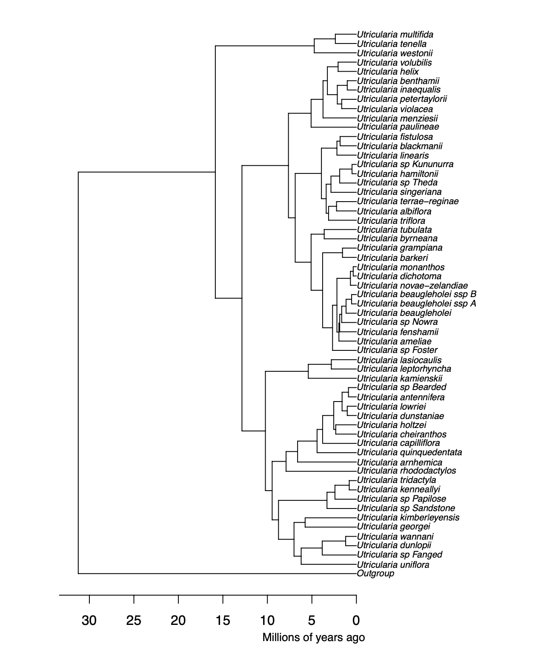

**Figure 1:** Digitised Utricularia phylogenetic tree from Jobson et al. (2017). The tree was manually digitised using the WebPlotDigitizer tool, allowing quantitative data extraction from the original graphical representation. Calibration of axes was performed based on estimated time (million years ago), ensuring accurate scaling. Data points corresponding to tips, nodes, and corners positions were digitised.

### **2.2.2 Data Collection: Carnivorous Plant Trap Types**

The phylogenetic model requires character states for a maximum likelihood analysis under the different models and Ancestral Character Estimation (ACE). Using sources from various papers and websites, species trap type, subtype, trapping zone, maximum trap size, and trap shape were collected for every possible species on phylogenetic trees acquired from publications (see **Table. 1**). Trap type refers to sticky leaf, snap, pitcher, or suction trap. In contrast, the sub-trap refers to the more detailed category, which helps to identify character states. For example, *Nepenthes* are pitcher plants, and at this stage, it can be concluded that all *Nepenthes* possess pitcher traps. But some *Nepenthes,* like *Nepenthes inermis* have a sticky inner wall, which suggests that it is a transitional trap that possesses both adhesive and pitcher traps, as mentioned earlier. The trapping zone refers to the essential characteristics to determine whether traps are specialised for aerial, ground, amphibious or aquatic. Maximum trap size and shape are for reference to help further interpret the evolution of carnivorous plant traps. Some species and genera were not available for trapping size and shape, as they are poorly studied (e.g. *Genlisea*) Using this information obtained from various sources, the character states have been determined, which are coded as a number (See **Table. 2**).

**Table 1:** Summary of character states for carnivorous plant traps for the the phylogenetic model. The dataset includes information on species trap type (sticky leaf, snap, pitcher, or suction trap), subtype for detailed categorisation, trapping zone specificity (aerial, ground, amphibious, or aquatic), and reference values for maximum trap size and shape. The table serves as a condensed representation of the original, extensive dataset, which was too large for inclusion in this thesis.

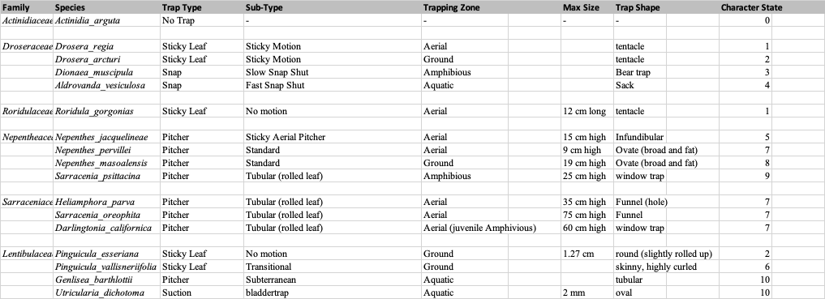

**Table 2:** Ancestral States coded for each character state. There are 11 states, including a non-carnivorous state, “No trap”. “Aerial both” and “Ground both” refer to transitional traps, which possess sticky and pitcher traps.

|  |  |  |
| --- | --- | --- |
| **Manual states** | **ACE states** | **Description** |
| no trap | 1 | no trap |
| 1 | 2 | aerial sticky |
| 2 | 3 | ground sticky |
| 3 | 4 | amphibious snap trap |
| 4 | 5 | aquatic snap trap |
| 5 | 6 | aerial both |
| 6 | 7 | ground both |
| 7 | 8 | aerial pitcher |
| 8 | 9 | ground pitcher |
| 9 | 10 | amphibious pitcher |
| 10 | 11 | aquatic pitcher |

### **2.2.3 Assembling Trees**

In this study, we employed V.PhyloMaker, a R package designed to provide subtrees from a large precalculated phylogenies of vascular plants, to construct a comprehensive and expansive phylogenetic tree (Jin & Qian, 2019). The utilisation of V.PhyloMaker is particularly advantageous for handling large datasets, as it incorporates a mega-tree derived from two recent publications, encompassing an extensive compilation of 74,533 species and including all families within extant vascular plants. Notably, the package excels in both speed and scalability, demonstrating its prowess in generating phylogenies for substantial species lists. Leveraging the capabilities of V.PhyloMaker, we integrated digitised trees obtained from publications, thus creating a phylogenetic framework that captures the evolutionary relationships of a diverse array of plant species. This approach enhances the efficiency of phylogenetic analysis and allows for incorporating specific genera or species into the broader phylogenetic context. Using V.PhyloMaker, if the digitised tree is dated, we assembled it with the larger tree.

When the digitised tree was not dated but had a branch length, we used the r8s program to produce an ultrametric, approximately time-scaled tree. The r8s program was pivotal in the temporal calibration and time scaling of non-dated digitised phylogenetic trees, effectively integrating them into a larger, dated phylogenetic framework (Sanderson, 2004). In the context of this study, r8s facilitated the precise time scaling of non-dated phylogenetic trees, aligning them with a broader phylogenetic context and providing insights into the evolutionary dynamics of the studied plant taxa. The digitised *Pinguicula* tree was not dated and had no branch lengths; however, we used the r8s program to impose several time contraints from the dated bigger *Pinguicula* subtree available in V.phyloMaker, and successfully combined with the larger tree.

As full model should include the gain and loss of plant carnivory along with trap transitions within carnivorous groups. However, running phylogenetic models on massive trees where the vast majority of taxa are noncarnivorous would be inefficient. To reduce the computational complexity and runtimes, we reduced the full tree to keep only the three successive noncarnivorous sister groups for each carnivorous clade, and then kept only one species per genus for those non-carnivorous plants. This reduced the tree from 74,533 species to around 2500 species.

### **2.2.4 Transition Rate Matrices**

Once the phylogenetic trees have been assembled, we made the score matrix for ten models after inferring scores for each species by their trap types. Matzke’s (2005) model (labeled “M05”, see **Table 3**) represents the pitcher hypothesis for the origin of the *Utricularia* trap as a series of transitions between 11 states. The model involves six parameters of transition: loss of carnivory, gain of carnivory, aerial to ground traps or reverse, ground to amphibious traps, amphibious to aquatic traps, and sticky to transitional into pitcher traps (see **Table. 4**). This model, informed by the arguments above, can be compared to various alternative or null models that postulate other allowed transitions. For example, the simple equal-rates (ER) null model allows all trap types to have equal rates of transition into any other trap type (see **Table. 5**). It represents one version of an “anything is possible” model. The rest of the models (see **Appendix 7)** are described in section 2.4.1. The rate matrix, organised as a square matrix, encapsulates the instantaneous rates of transitioning between different character states. When reading a rate matrix, the directional flow is from left (ancestral state) to top (descendant state). Diagonal elements denote remaining in the same state, while off-diagonal elements represent transition rates between distinct states. The motivation for the 6 rate parameters of the M05 model is given below. Rate 1 represents the loss of carnivory, which is indicated in the model that carnivorous traps lose their traps in ancestral state 2-11, thus transitioning into state 1. Rate 2 represents the gain of the carnivory, and, as mentioned earlier in this chapter, sticky leaf traps and aerial pitchers may have transitioned from the non-carnivorous plant (Darwin, 1875; Craw et al., 1999; Slack, 1988; Juniper et al.,1989). As Darwin (1875) observed the movement of sticky leaf traps, motion acquisition could occur gradually, with slight advantages gained at each state, which suggests that transition from aerial to ground sticky or reverse can be considered (Rate 3). Moreover, *Dionea* and *Aldrovanda* may have evolved from ground sticky leaf traps like *Drosera* (Lloyd, 1942; Juniper et al., 1989; Poppinga et al., 2016) and the transition of amphibious pitchers like *Sarracenia psittacina* from ground pitchers are imaginable, which are expressed in the model, transitioning from ground to amphibious traps (Rate 4). Transition from amphibious (*Sarracenia psittacina* and some *Genlisea*) to aquatic traps (*Aldrovanda* and *Utricularia*) is represented by Rate 5. Finally, the one-way transition from sticky leaf to transitional into pitcher traps is expressed as Rate 6.

**Table 3:** Score matrix of the pitcher hypothesis model. The numbers represent the rate of anagenetic transition in the trait.

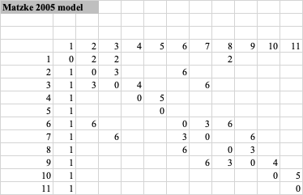

**Table 4:** Lists of rate parameters under the Matzke 2005 (M05) model: 1. Loss of carnivory, 2. Gain of carnivory, 3. Aerial to ground traps or reverse, 4. Ground to amphibious traps, 5. Amphibious to aquatic traps, and 6. Sticky to transitional into pitcher traps

|  |  |
| --- | --- |
| **Rates** | **Description** |
| 1 | loss of carnivory |
| 2 | gain of carnivory |
| 3 | aerial-ground or reverse |
| 4 | ground-amphibious |
| 5 | amphibious-aquatic |
| 6 | sticky-both-pitcher |

**Table 5:** Score matrix of equal-rates model. All character states have equal rates to transition into one another, represented by 1.

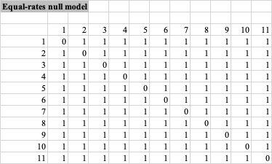

### **2.2.5 Model Selection by BioGeoBEARS**

Using ‘phytools (Revell 2023), Felsenstein's Pruning Algorithm was employed to calculate likelihoods – the probability of the observed trap type data under each proposed phylogenetic model. Felsenstein's Pruning Algorithm utilises the phylogenetic tree structure to calculate the probabilities of ancestral character states under proposed transition rates (Kosakovsky Pond et al., 2011). Start from the tips of the assembled phylogenetic tree, with each species labelled according to their observed trap types (e.g., bladder traps, pitcher traps, flypaper traps), the algorithm proceeds recursively toward the tree's root. The algorithm calculates the probability of each the trap type being ancestral to the observed tip data above it, for each internal node of the tree. If all descendant species share the same trap type, the ancestral node is assigned that trap type. If the descendant species have different trap types, the ancestral node is assigned likelihoods for each state. The algorithm continues to traverse the tree until the root is reached, assigning trap type likelihoods to each ancestral node. Once the algorithm has traversed the entire tree, the likelihoods are multiplied across all states, producing a total likelihood under the proposed model.

Maximum likelihood analysis under different models aims to assess the likelihood of the observed trap type distribution given each model and determine which model best fits the data. Maximum likelihood analysis is a statistical method commonly used in phylogenetics to estimate the parameters of a given model that maximises the probability of observing the observed data (Price et al., 2010). The analysis utilises a likelihood function that calculates the probability of observing the trap-type scores given the model's parameters for each model. The likelihood function considers the transition rates between trap types, the assignment of ancestral trap types, and the observed trap type scores for each species. The maximum likelihood estimation procedure searches for model parameters that maximise the likelihood function (Yang et al., 1995). They provide the parameter values that best explain the observed trap type distribution under each model, and these estimates allow us to evaluate the likelihood of the observed data given each model and compare the fit of the two models to the data. Finally, the Akaike Information Criterion (AIC) was used to assess the statistical significance of the difference in fit between the two models and determine which model better explains the trap type distribution (Lanfear et al., 2014). In the context of the maximum likelihood analysis for model comparison, the Akaike Information Criterion (AIC) is a widely used statistical measure to assess the relative goodness-of-fit of competing models. However, to account for the sample size and avoid bias in small sample sizes, the AICc was used in model selection, especially when the number of parameters in the models is relatively large compared to the sample size (Burnham & Anderson, 2004). This applies to one of our models, the ARD (all-rates-different) model, which consists of 110 parameters. By running the maximum likelihood analysis on the score matrices derived from the null hypothesis model and the pitcher hypothesis model, we can quantitatively evaluate the support for each model and determine which model best fits.

Under a chosen model, the probability of different ancestral trap types can be estimated for ancestral species that have not been directly observed. By combining the likelihood calculations described above with an “up-pass” passing probabilities from the root of the tree to the tips, the algorithm can assign probabilities to each possible ancestral trap type and for each node. To estimate the number and timing of transitions, ancestral character estimation can be supplemented with stochastic mapping, described below.

### **2.2.6 Ancestral Character Estimation by Phytools**

Under the best model selected based on the AIC and equal-rates null model, we performed ancestral character state estimation to infer the most likely trap types of ancestral species in the phylogenetic tree using ‘phytools’ (Revell, 2023). Ancestral state estimation allows us to reconstruct the trap-type evolution throughout the evolutionary history of the carnivorous plant lineage (Wilson et al., 2022). Phylogenetic stochastic mapping conducts probabilistic sampling of ancestral states to simulates possible evolutionary histories of trap types across the phylogenetic tree while considering the uncertainty associated with character changes. By implementing multiple stochastic simulations, each accounting for the variability in evolutionary processes, we generated a distribution of potential trap-type histories for each ancestral node. Phylogenetic stochastic mapping extends the traditional ancestral state estimation by acknowledging that character evolution is inherently stochastic. The approach allows for the exploration of alternative scenarios in which different trap types may have arisen at ancestral nodes, providing a more nuanced understanding of the potential states of these common ancestors. This probabilistic framework gives us insights into the likelihood of transitions between different trap types and the associated uncertainty in these evolutionary events. This integrative approach, combining the best model selected through AIC with phylogenetic stochastic mapping, enhances the robustness of our ancestral state reconstructions. It acknowledges the inherent complexity and uncertainty in the evolution of trap types within the carnivorous plant lineage. It provides a more comprehensive and realistic depiction of the ancestral states and their associated confidence intervals across the phylogeny.

## **2.3 Results**

### **2.3.1 Model Selection**

Ten models provided a maximized log-likelihood (LnL) and AIC with AIC weights for each model (**Table. 6**). The log-likelihoods, AICc values, and AICc weights serve as criteria for determining the model that most effectively fits our dataset. The model with the highest log-likelihood, the lowest AICc value, or the highest AICc weight is considered the optimal choice, indicating its superior fit to the observed data. The best-fitting model resM05 (pitcher hypothesis) was selected based on the lowest AIC value of 705.3996 and the highest AIC weight of 1 (**Table. 6**).

**Table 6:** AIC summary table for each phylogenetic model (see section 2.4.1 for model descriptions). Provided are model log-likelihoods, delta AIC (difference from the best/lowest AIC), relative likelihood (rel_likes), AIC values and weights.

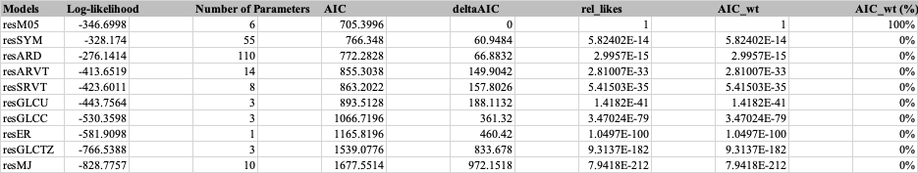

### **2.3.2 Phylogenetic Stochastic Mapping**

Under the best-fitting model resM05 (pitcher hypothesis) and resER (equal-rates null model), both models indicated the maximum transition rate among the states from 8 to 9, which represents the transition from aerial pitcher to ground pitcher traps. The best-fitting res05 model in the stochastic mapping analysis for the transition from state 8 to state 9 (representing the transition from ground pitcher to amphibious pitcher plant), the simulations yielded the highest mean transition rate of 37.6. The standard deviation of the transition rates was 3.41, indicating some variability in the estimates. The 95% credible interval, computed from the 2.5th to the 97.5th percentiles, ranges from 31.68 to 41.00. This interval reflects the uncertainty associated with the transition rate, suggesting that, with 95% confidence, the true rate falls within this range. The maximum mean transition rate observed among the specified states during the simulations was 37.6, further emphasising the central tendency of the estimated transition rates.

In the context of the equal-rates model, the transition from state 8 to state 9 was also the highest, and the stochastic mapping analysis produced a mean transition rate of 30.1, with a standard deviation of 1.73, indicating a relatively lower variability than other models. The 95% credible interval, calculated from the 2.5th to the 97.5th percentiles, ranges from 28 to 32, providing a measure of the uncertainty associated with the estimated transition rate. With 95% confidence, the true transition rate is expected to fall within this interval. The maximum mean transition rate observed among the specified states during the simulations was 30.1, underscoring the central tendency of the estimated transition rates under the equal-rates model.

Phylogenetic stochastic mapping for the best fitting resM05 indicates that the ancestral amphibious pitcher trap (light blue) and ancestral trap state of both transitional and ground sticky (light grey and orange) share the same common ancestor of ground and aerial pitcher trap (light green and dark green) (see **Fig. 2**). In contrast, resER, equal-rates model shows different ancestral state, where ancestral ground sticky trap (orange) and aquatic pitcher trap (blue) share the same common ancestor of aquatic pitcher trap (blue) (see **Fig. 3**).

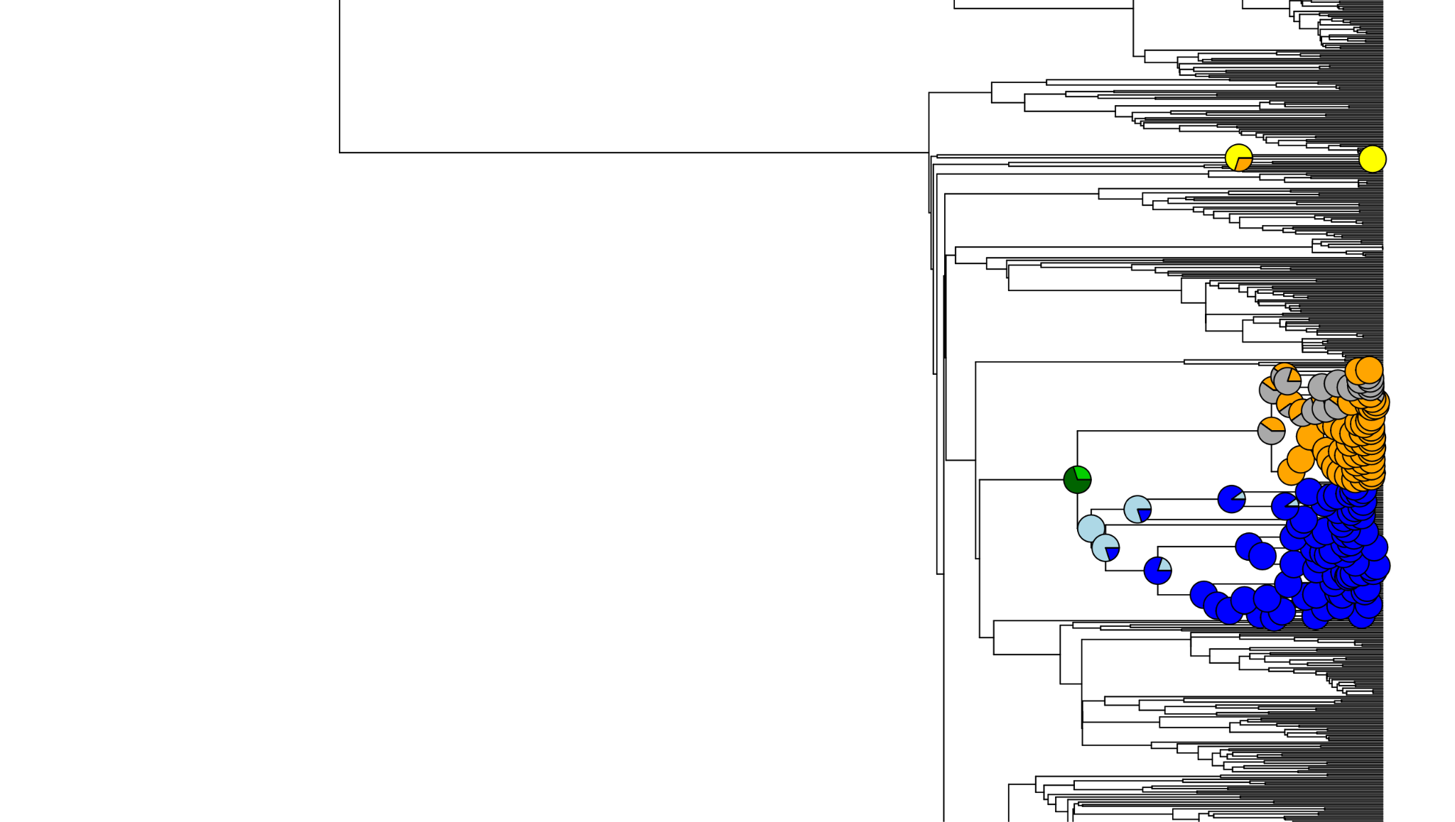

**Figure 2:** Phylogenetic stochastic mapping in the Lentibulariaceae under the best-fitting model, resM05, reveals that the common ancestor of ground and aerial pitcher traps (light green and dark green) is shared with the ancestral amphibious trap (light blue) and the ancestral trap state of both transitional and ground sticky traps (light grey and orange).

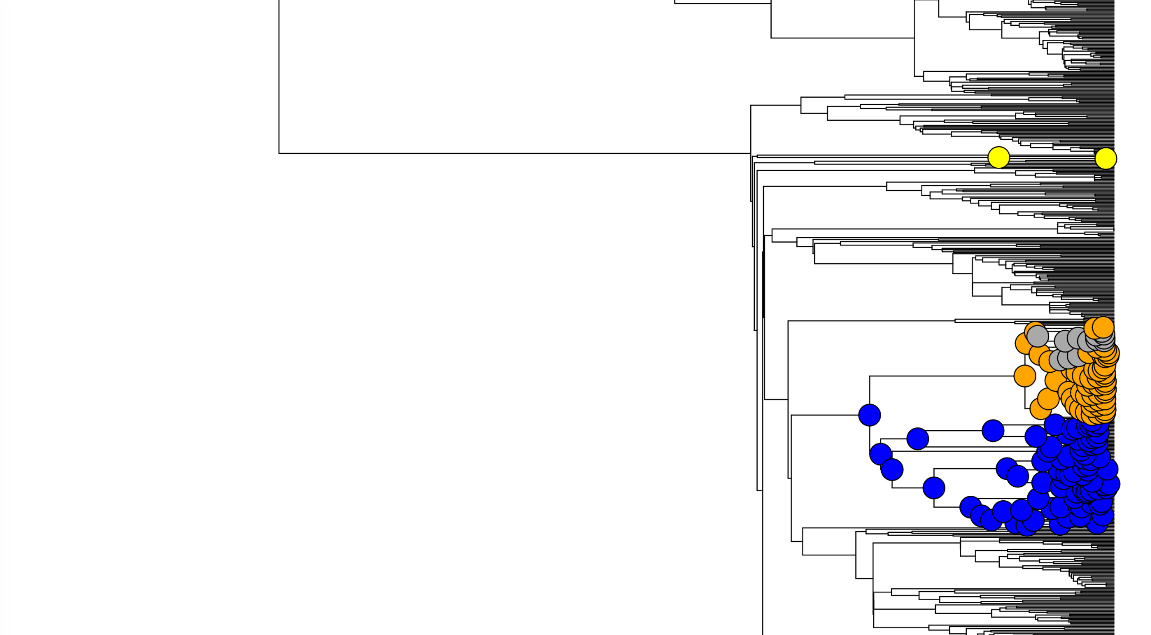

**Figure 3:** Phylogenetic stochastic mapping in the Lentibulariaceae under the equal-rates model (resER), the ancestral ground sticky trap (orange) and aquatic pitcher trap (blue) exhibit a different ancestral state, sharing the same common ancestor of the aquatic pitcher traps (blue).

## **2.4 Discussion**

### **2.4.1 Summary of Model Selection**

The best-fitting model resM05 (pitcher hypothesis) was selected based on the lowest AIC value of 705.3996 and the highest AIC weight of 1. The second and third models selected were resSYM (symmetric model) and resARD (all-rates different model). The Symmetric (SYM) and All Rates Different (ARD) models are standard options in discrete-character evolution software, frequently employed to study the transition dynamics between discrete character states, such as those representing traits in evolutionary biology. The Symmetric model assumes that the rates of change between any two character states are equivalent in both directions, adhering to a symmetric transition matrix. In contrast, the All Rates Different (ARD) model relaxes this constraint, allowing for distinct rates for forward and reverse transitions between character states. This implies that the process of transitioning from one state to another might occur at different rates than the reverse transition. Both models serve as valuable tools for understanding the evolutionary dynamics of discrete traits, with the Symmetric model representing a more constrained scenario and the ARD model offering greater flexibility by acknowledging potential asymmetries in the rates of character state changes.

These models scored log-likelihood of -328.174 and -276.1414, which are higher than the best-fitting model resM05 (-346.6998). At this stage, resSYM and resARD models are better fits than resM05; however, the AIC (Akaike Information Criterion) is a statistical measure that balances the goodness of fit of a model with the complexity of the model, effectively penalising models with more parameters (Akaike, 1987). In the context of the phylogenetic models resSYM, resARD, and resM05, the AIC scores provide a quantitative assessment of model performance. The AIC score incorporates both the likelihood of the model and the number of parameters, aiming to select the model that achieves the best balance between fit and simplicity. In comparing these models, resSYM and resARD exhibit higher log-likelihood scores (-328.174 and -276.1414, respectively) compared to the best-fitting model, resM05 (-346.6998). However, the AIC considers the number of parameters in addition to the likelihood. The resSYM model involves 55 parameters, resARD includes 110 parameters, and resM05 has only six parameters. AIC penalises models with more parameters, reflecting the principle of parsimony favouring simpler models that can adequately explain the data. Therefore, while resSYM and resARD may provide a better fit based on log-likelihood alone, the AIC score might favour resM05 due to its fewer parameters. This emphasises the trade-off between model complexity and goodness of fit, encouraging selection of a model that achieves a balance suitable for the specific dataset and research question.

Asymmetric and symmetric rate variation by trapping zone models (resARVT and resSRVT) refer to the implementation of rate transition parameters to the model based on trapping zones (aerial, ground, etc.) rather than trap types (pitcher, sticky, etc.). These models were selected at fourth and 5th based on their AIC and AIC weight. Regarding trapping zone models, resGLCTZ (gain-loss-change within trapping zone model) was selected at 9th. In addition, resGLCU (gain-loss-change unconstrained model) and resGLCC (gain-loss-change constrained model) were selected at 6th and 7th. The gain-loss-change unconstrained model allows for the loss of carnivory, gain of carnivory and the change between any types of trap. In contrast, the constrained model is limited in terms of allowing only for change within the same type of trap. These models are based on types of traps, rather than considering their trapping zones. As a result, these models' scores suggest that considering a singular aspect of the character state, whether it be the transition between trapping zones or types of traps, may offer an incomplete portrayal of the evolution of carnivorous plant traps. In particular, the resGLCTZ model, which focuses on gain-loss-change within trapping zones, and the resGLCU and resGLCC models, which respectively permit and restrict changes in trap types, underscore the significance of incorporating a comprehensive perspective. The resGLCU model, acknowledging the potential for loss and gain of carnivory and transitions across various trap types, recognises the complexity inherent in the evolutionary history of carnivorous plants. Conversely, the resGLCC model, constrained to changes within the same trap type, provides insights into more limited aspects of evolutionary dynamics. These nuanced distinctions emphasise that a holistic understanding of carnivorous plant trap evolution necessitates the consideration of both trapping zones and trap types. Moreover, models such as resARVT and resSRVT, which introduce rate transition parameters based on trapping zones over those exclusively centred on trap types (e.g., resM05), highlight the significance of ecological adaptations associated with different trapping zones. It underscores the inadequacy of a unidimensional approach and advocates for a multifaceted framework that encapsulates the varied dimensions of carnivorous plant trap evolution.

The equal-rate model (resER) refers to the model that all character states have equal rates to transition into any character states, which is ranked 8th under model selection. Finally, the worst model chosen was resMJ (Matzke 2005 Jump model), which refers to the model based on resM05, the pitcher hypothesis model; however, resM05 explains gradual evolutionary adaptation (e.g. sticky leaf traps evolve to transitional traps, and then into pitcher traps), whereas resMJ model skips the evolutionary step (e.g. sticky leaf traps evolve to pitcher traps, without developing through transitional state).

As articulated earlier, the equal-rate model (resER), ranking 8th under the model selection framework, posits uniform transition rates across all character states. While this model offers a simplified representation, its lower ranking suggests that a more nuanced consideration of variable transition rates is essential for accurately capturing the intricacies of carnivorous plant trap evolution. Conversely, the resMJ model, rooted in the resM05 pitcher hypothesis, emerges as the least favoured model within the selection process. This discrepancy suggests the importance of modeling the gradual, step-by-step nature of the evolutionary origin of complexity. The concept of a gradual evolutionary process posits that most evolutionary changes occur incrementally through gradual allelic substitution, leading to major adaptations over extended periods (Gould, 1980). The concept of gradualism, as opposed to punctuated equilibrium or abrupt jumps in evolutionary trajectories, has been a subject of extensive scientific discourse. Notably, the works of palaeontologists Stephen Jay Gould and Niles Eldredge proposed the theory of punctuated equilibrium, suggesting that evolutionary changes often occur rapidly in isolated populations, followed by prolonged periods of stability (Gould & Eldredge, 1977).

In the carnivorous plant trap evolution context, the gradual process posited by resM05 aligns with the broader understanding of evolutionary biology. For instance, a study on animal evolution by Douglas J. Emlen emphasises the role of gradual adaptation in shaping complex structures. The research on the evolution of exaggerated traits in insects that gradual changes in the function and form of weapons, driven by various mechanisms, contribute to the remarkable diversity observed in animal weapon structures (Emlen, 2008). This provides valuable perspectives on the significance of gradualism in diverse carnivorous plant traps.

### **2.4.2 Summary of Phylogenetic Stochastic Mapping**

From the ancestral state estimation, the transition from aerial pitcher to ground pitcher traps represents a crucial and evolutionarily significant shift in carnivorous plant traps. The observed high mean transition rates suggest a rapid and potentially adaptive process driving the emergence of new trap types. However, the variability in the estimates and the associated credible intervals highlight the complexity and nuances involved in capturing the true dynamics of these transitions. Further exploration and consideration of additional factors, such as environmental influences and potential selective pressures, would contribute to a more comprehensive understanding of the evolutionary processes shaping carnivorous plant traps.

The outcomes of phylogenetic stochastic mapping in the Lentibulariaceaeunder the best-fitting model, resM05 (pitcher hypothesis), and the equal-rates model, resER, reveal intriguing differences in the inferred ancestral states and transitions among trap types in carnivorous plants. In the resM05 model, the ancestral amphibious trap (light blue) and ancestral trap states of transitional/ ground sticky traps (light grey and orange) share a common ancestor with ground/ aerial pitcher traps (light green and dark green) (see Fig. 2). This suggests that, according to the resM05 model, the evolution of amphibious traps and the transitional/ ground sticky traps can be traced back to a common ancestor of ground/ aerial pitcher traps. Conversely, under the resER, equal-rates model, the inferred ancestral states depict a different scenario. The ancestral ground sticky trap (orange) and aquatic pitcher trap (blue) share a common ancestor with the aquatic pitcher trap (blue) (see Fig. 3). In this model, the evolutionary origin of ground sticky traps and aquatic pitcher traps can be traced back to a common ancestor of aquatic pitcher traps.

The discrepancy between these models, especially regarding the ancestral states and transitions, sheds light on the potential complexities in the evolutionary history of carnivorous plant traps. The resM05 model, aligned with the pitcher hypothesis, suggests a shared origin for amphibious traps and the transitional/ ground sticky traps with ground/ aerial pitcher traps. This implies a closer evolutionary relationship between these trap types and supports the pitcher hypothesis’s general idea of an evolutionary pathway between sticky traps, transitional traps, and pitcher traps; however, reconstructing the common ancestor of Lentibulariaceae as a pitcher-trapped plant challenges Matzke (2005)’s suggestion that this common ancestor would be a sticky-leaved or transitional-trap plant. The resER model, on the other hand, points towards a different evolutionary trajectory, where ancestral ground sticky traps and aquatic pitcher traps share a common ancestor. This suggests an independent evolution or divergence of ground sticky and aquatic pitcher traps from a common ancestor of aquatic pitcher traps, distinct from the one giving rise to the transitional/ aerial pitcher traps.

The observed differences in ancestral states between the models highlight the importance of testing alternative scenarios in understanding the evolution of carnivorous plant traps. Different evolutionary models lead to different estimates of evolutionary history, so finding the best-fitting models is an important step increasing accuracy. An additional advantage of stastically comparing models is that an initially verbal argument for an evolutionary pathway from sticky traps to pitcher traps to aquatic pitchers is converted into a statistical hypothesis test. The M05-inferred ancestral state of aerial/ ground pitcher traps as ancestral in the Lentibulariaceae, aligns well with proposed pitcher hypothesis we proposed to explain the origin of *Utricularia* bladder traps as essentially miniaturised pitcher traps. Further investigations into the ecological contexts, functional adaptations, and potential ecological drivers for different trap types could provide valuable insights into the nuanced dynamics of carnivorous plant evolution. The evolution of trap size could also be modelled in future work.

### **2.4.3 Concluding Remarks**

This research showed that our model selection process identified resM05 (pitcher hypothesis) as the best-fitting model, emphasising its suitability for capturing carnivorous plant trap evolution complexities. Despite higher log-likelihood scores for resSYM and resARD, the Akaike Information Criterion (AIC) underscored the importance of balancing goodness of fit with model simplicity. The nuanced nature of evolutionary dynamics became evident with the incorporation of trapping zone models (resARVT and resSRVT) and gain-loss-change models (resGLCTZ, resGLCU, and resGLCC), highlighting the need for a multifaceted framework considering both trapping zones and trap types.

While the equal-rate model (resER) and resMJ model provided alternative perspectives, their lower rankings reinforced the significance of acknowledging gradual evolutionary processes. The observed differences in ancestral states between resM05 and resER showed potential complexities in carnivorous plant trap evolution. The alignment of our results with the pitcher hypothesis suggests a shared origin for amphibious traps and transitional/ground sticky traps with ground/aerial pitcher traps. This supports the idea that *Utricularia* bladder traps are miniaturised pitcher traps. However, further models should be explored, as challenges arose in explaining the gradual evolution from sticky traps to pitcher traps through transitional traps: the details of ancestral state estimation under the M05 model suggest that the *Pinguicula* flypaper traps evolved from a pitcher ancestor. While not impossible (see *N. inermis*), it may be that a more constrained version of M05 would produce a simpler scenario.

The observed patterns underline the need for cautious interpretation and consideration of multiple models to comprehend the intricate evolutionary processes shaping these captivating adaptations. Our research serves as a foundation for further modeling to provide insights into the evolutionary history of carnivorous plant traps. Moving forward, in-depth analyses of ecological contexts, functional adaptations, trap size, and potential ecological drivers for different trap types will be essential. This research lays a solid groundwork, inviting further investigations and contributing to a broader understanding of carnivorous plant trap evolution.

## **Chapter 3: General Discussion**

### **3.1 Thesis Aim**

The aim of this thesis is to test the validity of the pitcher hypothesis, which posits that *Utricularia* traps represent miniaturised pitcher plants, and to explore the broader implications of this hypothesis for understanding the evolutionary origin and adaptive significance of *Utricularia* traps. This research seeks to provide robust evidence either supporting or challenging the pitcher hypothesis through comprehensive statistical model comparison and phylogenetic stochastic mapping. Additionally, this study aims to lay a solid groundwork, inviting further investigations and contributing to a broader understanding of carnivorous plant trap evolution. The outcomes of this study are anticipated to serve as a foundational resource, offering valuable insights that will guide and inspire future researchers in their endeavours to unravel the complexities of carnivorous plant trap evolution.

### **3.2 Overview**

In this honours project spanning 12 weeks, an unconventional approach was employed to acquire phylogenetic data for carnivorous plants. Instead of traditional bioinformatics methods, phylogenetic trees for various carnivorous plant genera were extracted from published studies. Notably, the *Utricularia* tree from Jobson et al. (2017) was a key example generated through Bayesian molecular clock analysis. The digitisation of these trees using WebPlotDigitizer facilitated further quantitative analysis. Information on species trap types, subtypes, trapping zones, maximum trap size, and trap shape was collected from diverse sources for trap-type data. Character states were numerically coded to represent these features, allowing for subsequent analysis. The phylogenetic trees were assembled using V.PhyloMaker, a robust R package capable of handling large datasets efficiently. The r8s program was employed for temporal calibration and integrating non-dated digitised trees into a broader, dated phylogenetic context.

Transition rate matrices were constructed to model the evolution of carnivorous plant traps. Ten models, including the pitcher hypothesis Matzke (2005) model, were developed to infer transition rates between trap types, considering parameters such as loss of carnivory, gain of carnivory, and transitions between different trap types. Phytools, specifically Felsenstein's Pruning Algorithm, was utilised for model selection, with the best-fitting model identified as resM05 (pitcher hypothesis) based on the lowest AIC value and highest AIC weight.

Subsequently, ancestral state estimation was conducted using phylogenetic stochastic mapping under the best-fitting model (resM05) and the equal-rates null model (resER). This analysis revealed intriguing differences in inferred ancestral states and transitions among trap types, shedding light on potential complexities in the evolutionary history of carnivorous plant traps. The observed ancestral states under resM05, aligned with the pitcher hypothesis, suggested that the common ancestor of Lentibulariaceae’s amphibious traps and transitional/ground sticky traps was a ground or aerial pitcher trap. Conversely, under the poorly-fitting equal-rates model (resER), the inferred ancestral states pointed towards a different trajectory, indicating an origin of ground sticky traps from a common ancestor of aquatic pitcher traps.

In summary, this project employed an alternative approach to phylogenetic data acquisition and subsequent analysis, offering insights into the evolution of carnivorous plant traps, particularly focusing on *Utricularia*. The results underscore the importance of considering multiple models and perspectives to capture the complexity of evolutionary processes in these fascinating adaptations.

### **3.3 Implications of Research**

This study offers profound insights into several key aspects by investigating the origins and transformations of the bladder trap in *Utricularia* within the context of its phylogenetic relationships and comparative morphology. Firstly, this research revealed the evolutionary patterns and diversification of trap types within the carnivorous plant lineage. The evolutionary transitions from simpler flypaper traps to more complex pitcher-like structures and, eventually, bladder traps provide a comprehensive framework for understanding carnivorous plants' adaptive radiation and diversification. The pitcher hypothesis model was a better fit; the study revealed the potential pathways and mechanisms through which trap types have evolved and diversified over time, thus contributing to our knowledge of the mechanisms driving the remarkable morphological variations in these plants. In addition, the research enabled us to understand ancestral trap types through ancestral state estimation. The research sheds light on the significance of gradualism in the evolutionary processes of carnivorous plants, particularly in the context of trap development. By favouring the pitcher hypothesis model (resM05) over alternatives like the jump model (resMJ), which skips transitional states, the study underscores the importance of acknowledging incremental changes in the evolution of complex traits. This aligns with broader discussions in evolutionary biology, emphasising the role of gradual adaptation in shaping diverse and intricate structures. The recognition of gradualism in the context of carnivorous plant traps provides a valuable contribution to the ongoing discourse on the tempo and mode of evolution. Furthermore, utilising the Akaike Information Criterion (AIC) in model selection highlights the need for a balanced approach between model complexity and goodness of fit. While models with higher log-likelihood scores might seem appealing, the AIC emphasises the importance of parsimony, favouring simpler models that effectively capture the essence of the data without unnecessary complexity. This methodological consideration has broader implications for phylogenetic studies, encouraging researchers to weigh the trade-off between model intricacy and explanatory power in their analyses. Introducing trapping zone models (resARVT and resSRVT) and gain-loss-change models (resGLCTZ, resGLCU, and resGLCC) provides a multifaceted perspective on carnivorous plant trap evolution. The recognition that trapping zones, in addition to trap types, play a crucial role in understanding the dynamics of carnivorous plant trap evolution broadens the scope of ecological considerations in evolutionary studies. This holistic approach emphasises the interconnectedness of morphological changes and ecological niches, contributing to a more comprehensive understanding of the factors influencing the evolution of trap structures. Moreover, the research underscores the importance of considering alternative scenarios in ancestral state estimation. The discrepancies between the pitcher hypothesis model (resM05) and the equal-rates model (resER) regarding ancestral states and transitions highlight the complexity of carnivorous plant trap evolution. This complexity suggests that various factors influence trap development, including selective pressures, environmental conditions, and stochastic events. Researchers should remain cautious in drawing definitive conclusions and recognise the need for ongoing exploration and refinement of models to capture the full spectrum of evolutionary processes.

### **3.4 Limitations and Future Directions**

#### **3.4.1 Study Limitations**

The study on the evolutionary dynamics of carnivorous plant traps, particularly focusing on *Utricularia*, has its inherent limitations that should be considered. One significant constraint pertains to the data utilised in the analysis. The study's scope and depth may be contingent upon the availability and completeness of existing data on *Utricularia* and other carnivorous plant lineages. Incomplete or limited datasets could potentially introduce biases or gaps in our understanding of trap evolution. Addressing this limitation would require acquiring more extensive datasets or capitalising on future discoveries in carnivorous plant research. Another set of limitations arises from the modelling assumptions inherent in the study. While robust, the chosen models and methodologies involve certain assumptions about evolutionary processes. Simplifications within these models might not fully capture the intricacies of trap evolution. Exploring alternative modelling approaches could provide a more nuanced and comprehensive understanding of the evolutionary dynamics under consideration. Additionally, assessing the sensitivity of results to different modelling assumptions would contribute to a more robust interpretation of findings. The study's ecological context is another area of limitation. While the research delves into trap evolution, the intricate interplay between ecological factors and the evolutionary trajectories of carnivorous plants may not be fully captured. This limitation prompts future research avenues to explore the specific ecological triggers, nutrient dynamics, and interactions with other species that shape the evolution of carnivorous plant traps. Temporal resolution represents a further limitation. The study employs r8s for temporal calibration of non-dated trees, introducing a degree of uncertainty into the temporal aspects of trap evolution. Improved dating methods or access to more dated samples could enhance the temporal resolution of the study and provide a more accurate timeline for the evolutionary events under investigation.

#### **3.4.2 Future Directions**

Addressing the limitations outlined above opens up promising avenues for future research in the field of carnivorous plant trap evolution. One potential direction involves conducting ecological experiments in natural environments. Such experiments could shed light on the ecological triggers and selective pressures that drive the evolution of carnivorous plant traps. Exploring factors such as nutrient availability, prey abundance, and interspecies interactions in situ would provide a more holistic understanding of the ecological context of carnivorous plant adaptations. Integrating genomic analysis into future studies represents another fruitful direction. By delving into the genetic underpinnings of carnivorous adaptations, researchers can better understand the molecular mechanisms driving trap development. Comparative genomics, in particular, could unveil key genes associated with different trap types and their evolution. A focus on functional morphology studies offers yet another avenue for future exploration. Detailed examinations of the functional morphology of various trap types can deepen our understanding of how specific adaptations contribute to prey capture and nutrient acquisition. This could involve anatomical studies and functional experiments to elucidate the mechanisms behind the diverse trapping strategies observed in carnivorous plants. Adding further adding species to our trap type database (for example, most of the large carnivorous genera are only partially sampled by published phylogenies) may increase our ability to statistically distinguish similar phylogenetic models. Comparative analyses across different plant families can reveal commonalities and differences in trap evolution, contributing to a more holistic understanding of this intriguing phenomenon. Finally, investigating long-term evolutionary trends represents a valuable future direction. This could involve exploring fossil evidence or examining the paleobiogeography of carnivorous plants may help gain insights into the extended temporal perspective of carnivorous plant trap evolution. Such long-term perspectives could reveal patterns and trends that may not be apparent in phylogenies of living species.

### **3.5 Conclusion**

In conclusion, this thesis aimed to statistically test the pitcher hypothesis regarding *Utricularia* traps, employing a unique approach to phylogenetic data acquisition and analysis. The results provided robust evidence supporting the pitcher hypothesis, emphasising the importance of gradual evolutionary transitions in models explaining complexity in trap evolution. The implications of the research extend to broader discussions on gradualism in evolution, model selection methodologies, and the interconnectedness of ecological factors and trap evolution. While acknowledging study limitations, future directions focus on ecological experiments, genomic analysis, functional morphology studies, taxonomic expansion, and investigations into long-term evolutionary trends. This work contributes significantly to the understanding of carnivorous plant trap evolution, offering a foundation for continued exploration and inspiring future research endeavours.

# **References**

Adamec, L. (2018). Biological flora of Central Europe: Aldrovanda vesiculosa L. *Perspectives in Plant Ecology, Evolution and Systematics*, *35*, 8–21.<https://doi.org/10.1016/j.ppees.2018.10.001>

Adlassnig, W., Peroutka, M., & Lendl, T. (2011). Traps of carnivorous pitcher plants as a habitat: Composition of the fluid, biodiversity and mutualistic activities. *Annals of Botany*, *107*(2), 181–194.

Albert, V. A., Jobson, R. W., Michael, T. P., & Taylor, D. J. (2010). The carnivorous bladderwort (Utricularia, Lentibulariaceae): A system inflates. *Journal of Experimental Botany*, *61*(1), 5–9.<https://doi.org/10.1093/jxb/erp349>

Akaike, H. (1987). Factor analysis and AIC. *Psychometrika*, *52*(3), 317–332.

<https://doi.org/10.1007/BF02294359>

Baucom, R. S. (2019). Evolutionary and ecological insights from herbicide-resistant weeds: What have we learned about plant adaptation, and what is left to uncover? *New Phytologist*, *223*(1), 68–82.<https://doi.org/10.1111/nph.15723>

Biteau, F., Nisse, E., Hehn, A., Miguel, S., Hannewald, P., & Bourgaud, F. (2012). A Rapid and Efficient Method for Isolating High Quality DNA from Leaves of Carnivorous Plants from the Drosera Genus. *Molecular Biotechnology*, *51*(3), 247–253.<https://doi.org/10.1007/s12033-011-9462-y>

Böhm, J., Scherzer, S., Krol, E., Kreuzer, I., von Meyer, K., Lorey, C., Mueller, T. D., Shabala, L., Monte, I., Solano, R., Al-Rasheid, K. A. S., Rennenberg, H., Shabala, S., Neher, E., & Hedrich, R. (2016). The Venus Flytrap Dionaea muscipula Counts Prey-Induced Action Potentials to Induce Sodium Uptake. *Current Biology*, *26*(3), 286–295.<https://doi.org/10.1016/j.cub.2015.11.057>

Bopp, M., & Weber, I. (1981). Hormonal regulation of the leaf blade movement of Drosera capensis. *Physiologia Plantarum*, *53*(4), 491–496.<https://doi.org/10.1111/j.1399-3054.1981.tb02738.x>

Burnham, K. P., & Anderson, D. R. (2004). Multimodel Inference: Understanding AIC and BIC in Model Selection. *Sociological Methods & Research*, *33*(2), 261–304.<https://doi.org/10.1177/0049124104268644>

Carmesin, C. F., Fleischmann, A. S., Klepsch, M. M., Westermeier, A. S., Speck, T., Jansen, S., & Poppinga, S. (2021). Structural gradients and anisotropic hydraulic conductivity in the enigmatic eel traps of carnivorous corkscrew plants (Genlisea spp.). *American Journal of Botany*, *108*(12), 2356–2370.<https://doi.org/10.1002/ajb2.1779>

Craw, R. C., Grehan, J. R., & Heads, M. J. (1999). Panbiogeography: Tracking the History of Life. Oxford University Press.

Davis, A. L., Babb, M. H., Lowe, M. C., Yeh, A. T., Lee, B. T., & Martin, C. H. (2019). Testing Darwin’s Hypothesis about the Wonderful Venus Flytrap: Marginal Spikes Form a “Horrid Prison” for Moderate-Sized Insect Prey. *The American Naturalist*, *193*(2), 309–317.<https://doi.org/10.1086/701433>

Darwin Correspondence Project, “Letter no. 10085,” accessed on 6 June 2023, <https://www.darwinproject.ac.uk/letter/?docId=letters/DCP-LETT-10085.xml>

Di Giusto, B., Bessière, J.-M., Guéroult, M., Lim, L. B. L., Marshall, D. J., Hossaert-Mckey, M., & Gaume, L. (2010). Flower-scent mimicry masks a deadly trap in the carnivorous plant Nepenthes rafflesiana. *Journal of Ecology*, *98*(4), 845–856.

Domínguez, Y., Panfet Valdés, C. M., & de Miranda, V. F. O. (2012). New features of Cuban endemic Pinguicula filifolia (Lentibulariaceae) and considerations on its habitat and ecology. *Flora - Morphology, Distribution, Functional Ecology of Plants*, *207*(11), 838–841.<https://doi.org/10.1016/j.flora.2012.09.009>

Ellison, A. M., & Gotelli, N. J. (2001). Evolutionary ecology of carnivorous plants. *Trends in Ecology & Evolution*, *16*(11), 623–629.<https://doi.org/10.1016/S0169-5347(01)02269-8>

Emlen, D. J. (2008). The Evolution of Animal Weapons. *Annual Review of Ecology, Evolution, and Systematics*, *39*, 387–413.

Forterre, Y., Skotheim, J. M., Dumais, J., & Mahadevan, L. (2005). How the Venus flytrap snaps. *Nature*, *433*(7024), 421–425.<https://doi.org/10.1038/nature03185>

Gaascht, F., Dicato, M., & Diederich, M. (2013). Venus Flytrap (Dionaea muscipula Solander ex Ellis) Contains Powerful Compounds that Prevent and Cure Cancer. *Frontiers in Oncology*, *3*, 202.<https://doi.org/10.3389/fonc.2013.00202>

Gibson, T. C. (1991). Differential escape of insects from carnivorous plant traps. American

Midland Naturalist, 125(1), 55-62.

Givnish, T. J., Burkhardt, E. L., Happel, R. E., & Weintraub, J. D. (1984). Carnivory in the bromeliad Brocchinia reducta, with a cost/benefit model for the general restriction of carnivorous plants to sunny, moist, nutrient-poor habitats. *American Naturalist*, *124*, 479-497.

Gould, S. J. (1980). Is a New and General Theory of Evolution Emerging? *Paleobiology*, *6*(1), 119–130.

Gould, S. J., & Eldredge, N. (1977). Punctuated Equilibria: The Tempo and Mode of Evolution Reconsidered. *Paleobiology*, *3*(2), 115–151.

Hotti, H., Gopalacharyulu, P., Seppänen-Laakso, T., & Rischer, H. (2017). Metabolite profiling of the carnivorous pitcher plants Darlingtonia and Sarracenia. *PLoS ONE*, *12*(2), e0171078.<https://doi.org/10.1371/journal.pone.0171078>

Jin, Y., & Qian, H. (2019). V.PhyloMaker: An R package that can generate very large phylogenies for vascular plants. *Ecography*, *42*(8), 1353–1359.<https://doi.org/10.1111/ecog.04434>

Joyeux, M. (2013). Elastic models of the fast traps of carnivorous Dionaea and Aldrovanda. *Physical Review E*, *88*(3), 034701.<https://doi.org/10.1103/PhysRevE.88.034701>

Jürgens, A., Witt, T., Sciligo, A., & El-Sayed, A. M. (2015). The effect of trap colour and trap-flower distance on prey and pollinator capture in carnivorous Drosera species. *Functional Ecology*, *29*(8), 1026–1037.

Juniper, B. E., Robins, R. J., & Joel, D. M. (1989). The Carnivorous Plants. Academic Press.

Körner, C. (2016). Plant adaptation to cold climates. *F1000Research*, *5*.<https://doi.org/10.12688/f1000research.9107.1>

Kosakovsky Pond, S. L., Murrell, B., Fourment, M., Frost, S. D. W., Delport, W., & Scheffler, K. (2011). A Random Effects Branch-Site Model for Detecting Episodic Diversifying Selection. *Molecular Biology and Evolution*, *28*(11), 3033–3043.<https://doi.org/10.1093/molbev/msr125>

Krupa, J. J., Hopper, K. R., Gruber, S. B., Schmidt, J. M., & Harwood, J. D. (2020). Plant–animal interactions between carnivorous plants, sheet‐web spiders, and ground‐running spiders as guild predators in a wet meadow community. *Ecology and Evolution*, *10*(11), 4762–4772.<https://doi.org/10.1002/ece3.6230>

Kubitzki, K. (2003). Droseraceae. In K. Kubitzki & C. Bayer (Eds.), *Flowering Plants · Dicotyledons: Malvales, Capparales and Non-betalain Caryophyllales* (pp. 198–202). Springer.<https://doi.org/10.1007/978-3-662-07255-4_21>

Laakkonen, L., Jobson, R. W., & Albert, V. A. (2006). A New Model for the Evolution of Carnivory in the Bladderwort Plant (Utricularia): Adaptive Changes in Cytochrome c Oxidase (COX) Provide Respiratory Power. *Plant Biology*, *8*(6), 758–764.<https://doi.org/10.1055/s-2006-924459>

Lanfear, R., Calcott, B., Kainer, D., Mayer, C., & Stamatakis, A. (2014). Selecting optimal partitioning schemes for phylogenomic datasets. *BMC Evolutionary Biology*, *14*, 82.<https://doi.org/10.1186/1471-2148-14-82>

Lee, L., Zhang, Y., Ozar, B., Sensen, C. W., & Schriemer, D. C. (2016). Carnivorous Nutrition in Pitcher Plants ( *Nepenthes* spp.) via an Unusual Complement of Endogenous Enzymes. *Journal of Proteome Research*, *15*(9), 3108–3117.<https://doi.org/10.1021/acs.jproteome.6b00224>

Lin, Q., Ané, C., Givnish, T. J., & Graham, S. W. (2021). A new carnivorous plant lineage (Triantha) with a unique sticky-inflorescence trap. *Proceedings of the National Academy of Sciences of the United States of America*, *118*(33), e2022724118.<https://doi.org/10.1073/pnas.2022724118>

Lloyd, F. E. (1942). The carnivorous plants, by Francis Ernest Lloyd. *Chronica*

*Botanica Company.* <https://www.biodiversitylibrary.org/item/27249>

Major, J. (1980). Plant Strategies. *Ecology*, *61*(2), 438–439.<https://doi.org/10.2307/1935202>

Mithöfer, A. (2011). Carnivorous pitcher plants: Insights in an old topic. *Phytochemistry*, *72*(13), 1678–1682.<https://doi.org/10.1016/j.phytochem.2010.11.024>

Mithöfer, A. (2021). A spotlight on prey-induced metabolite dynamics in sundew. A commentary on: ‘Metabolomic analysis reveals reliance on secondary plant metabolites to facilitate carnivory in the Cape sundew, Drosera capensis.’ *Annals of Botany*, *128*(3), v–vi.<https://doi.org/10.1093/aob/mcab093>

Moon, D. C., Rossi, A. M., Depaz, J., McKelvey, L., Elias, S., Wheeler, E., & Moon, J. (2010). Ants provide nutritional and defensive benefits to the carnivorous plant Sarracenia minor. *Oecologia*, *164*(1), 185–192.

Moran, J. A. (1996). Pitcher Dimorphism, Prey Composition and the Mechanisms of Prey Attraction in the Pitcher Plant Nepenthes Rafflesiana in Borneo. *Journal of Ecology*, *84*(4), 515–525.<https://doi.org/10.2307/2261474>

Müller, U. K., Berg, O., Schwaner, J. M., Brown, M. D., Li, G., Voesenek, C. J., & van Leeuwen, J. L. (2020). Bladderworts, the smallest known suction feeders, generate inertia-dominated flows to capture prey. *New Phytologist*, *228*(2), 586–595.<https://doi.org/10.1111/nph.16726>

Newell, S. J., & Nastase, A. J. (1998). Efficiency of Insect Capture by Sarracenia purpurea (Sarraceniaceae), the Northern Pitcher Plant. *American Journal of Botany*, *85*(1), 88–91.<https://doi.org/10.2307/2446558>

Pavlovič, A., Jakšová, J., & Novák, O. (2017). Triggering a false alarm: Wounding mimics prey capture in the carnivorous Venus flytrap (<em>Dionaea muscipula</em>). *The New Phytologist*, *216*(3), 927–938.

Płachno, B. J., Link to external site, this link will open in a new window, Silva, S. R., Link to external site, this link will open in a new window, Świątek, P., Dixon, K. W., Lustofin, K., Seber, G. C., Miranda, V. F. O., & Link to external site, this link will open in a new window. (2020). Structural Features of Carnivorous Plant (Genlisea, Utricularia) Tubers as Abiotic Stress Resistance Organs. *International Journal of Molecular Sciences*, *21*(14), 5143.<https://doi.org/10.3390/ijms21145143>

Poppinga, S., Hartmeyer, S. R. H., Masselter, T., Hartmeyer, I., & Speck, T. (2013). Trap diversity and evolution in the family Droseraceae. *Plant Signaling & Behavior*, *8*(7), e24685.<https://doi.org/10.4161/psb.24685>

Poppinga, S., Hartmeyer, S. R. H., Seidel, R., Masselter, T., Hartmeyer, I., & Speck, T. (2012). Catapulting Tentacles in a Sticky Carnivorous Plant. *PLoS ONE*, *7*(9), e45735.<https://doi.org/10.1371/journal.pone.0045735>

Poppinga, S., Knorr, N., Ruppert, S., & Speck, T. (2022). Chemonastic Stalked Glands in the Carnivorous Rainbow Plant Byblis gigantea LINDL. (Byblidaceae, Lamiales). *International Journal of Molecular Sciences*, *23*(19), 11514.<https://doi.org/10.3390/ijms231911514>

Poppinga, S., Masselter, T., & Speck, T. (2013). Faster than their prey: New insights into the rapid movements of active carnivorous plants traps. *BioEssays*, *35*(7), 649–657.<https://doi.org/10.1002/bies.201200175>

Poppinga, S., Tim, K., Amélie, M., Speck, O., & Speck, T. (2016). Comparative kinematical analyses of Venus flytrap (Dionaea muscipula) snap traps. *Beilstein Journal of Nanotechnology*, *7*, 664–674.<https://doi.org/10.3762/bjnano.7.59>

Price, M. N., Dehal, P. S., & Arkin, A. P. (2010). FastTree 2 – Approximately Maximum-Likelihood Trees for Large Alignments. *PLoS ONE*, *5*(3), e9490.<https://doi.org/10.1371/journal.pone.0009490>

Rice, B. (2007). Carnivorous plants with hybrid trapping strategies. *Carnivorous Plant Newsletter*, *36*(1), 23–27.<https://doi.org/10.55360/cpn361.br152>

Sachse, R., Westermeier, A., Mylo, M., Nadasdi, J., Bischoff, M., Speck, T., & Poppinga, S. (2020). Snapping mechanics of the Venus flytrap (Dionaea muscipula). *Proceedings of the National Academy of Sciences of the United States of America*, *117*(27), 16035–16042.<https://doi.org/10.1073/pnas.2002707117>

Sanderson, M. J. (n.d.). *R8s, version 1.70 User’s Manual*.

Schnell, D. E. (2002). Carnivorous Plants of the United States and Canada. Timber Press.

Scorza, L. C. T., & Dornelas, M. C. (2011). Plants on the move. *Plant Signaling & Behavior*, *6*(12), 1979–1986.<https://doi.org/10.4161/psb.6.12.18192>

Singh, K., Reyes, R. C., Campa, G., Jr, Brown, M. D., Hidalgo, F., Berg, O., Müller, U. K., & Link to external site, this link will open in a new window. (2020). Suction Flows Generated by the Carnivorous Bladderwort Utricularia—Comparing Experiments with Mechanical and Mathematical Models. *Fluids*, *5*(1), 33.<https://doi.org/10.3390/fluids5010033>

Skotheim, J. M., & Mahadevan, L. (2005). Physical Limits and Design Principles for Plant and Fungal Movements. *Science*, *308*(5726), 1308–1310.

Srivastava, A., Rogers, W. L., Breton, C. M., Cai, L., & Malmberg, R. L. (2011). Transcriptome Analysis of Sarracenia, an Insectivorous Plant. *DNA Research: An International Journal for Rapid Publication of Reports on Genes and Genomes*, *18*(4), 253–261.<https://doi.org/10.1093/dnares/dsr014>

Tagawa, K., & Watanabe, M. (2021). Group foraging in carnivorous plants: Carnivorous plant Drosera makinoi (Droseraceae) is more effective at trapping larger prey in large groups. *Plant Species Biology*, *36*(1), 114–118.<https://doi.org/10.1111/1442-1984.12290>

Voigt, D., Gorb, E., & Gorb, S. (2009). Hierarchical organisation of the trap in the protocarnivorous plant Roridula gorgonias (Roridulaceae). *Journal of Experimental Biology*, *212*(19), 3184–3191.<https://doi.org/10.1242/jeb.034280>

Voigt, D., & Gorb, S. (2010). Desiccation resistance of adhesive secretion in the protocarnivorous plant Roridula gorgonias as an adaptation to periodically dry environment. *Planta*, *232*(6), 1511–1515.

Vries, J. de, & Archibald, J. M. (2018). Plant evolution: Landmarks on the path to terrestrial life. *The New Phytologist*, *217*(4), 1428–1434.

Westermeier, A. S., Fleischmann, A., Link to external site, this link will open in a new window, Müller, K., Schäferhoff, B., Rubach, C., Speck, T., Link to external site, this link will open in a new window, Poppinga, S., & Link to external site, this link will open in a new window. (2017). Trap diversity and character evolution in carnivorous bladderworts (Utricularia, Lentibulariaceae). *Scientific Reports (Nature Publisher Group)*, *7*, 1–24.<https://doi.org/10.1038/s41598-017-12324-4>

Westermeier, A. S., Sachse, R., Poppinga, S., Vögele, P., Adamec, L., Speck, T., & Bischoff, M. (2018). How the carnivorous waterwheel plant (Aldrovanda vesiculosa) snaps. *Proceedings of the Royal Society B: Biological Sciences*, *285*(1878), 20180012.<https://doi.org/10.1098/rspb.2018.0012>

Westoby, M., Falster, D. S., Moles, A. T., Vesk, P. A., & Wright, I. J. (2002). Plant Ecological Strategies: Some Leading Dimensions of Variation between Species. *Annual Review of Ecology and Systematics*, *33*, 125–159.

Wilson, J. D., Mongiardino Koch, N., & Ramírez, M. J. (2022). Chronogram or phylogram for ancestral state estimation? Model-fit statistics indicate the branch lengths underlying a binary character’s evolution. *Methods in Ecology and Evolution*, *13*(8), 1679–1689.<https://doi.org/10.1111/2041-210X.13872>

Worley, A. C., & Harder, L. D. (1996). Size-Dependent Resource Allocation and Costs of Reproduction in Pinguicula Vulgaris (Lentibulariaceae). *Journal of Ecology*, *84*(2), 195–206.<https://doi.org/10.2307/2261355>

Yang, Z., Goldman, N., & Friday, A. (1995). Maximum Likelihood Trees from DNA Sequences: A Peculiar Statistical Estimation Problem. *Systematic Biology*, *44*(3), 384–399.<https://doi.org/10.2307/2413599>

Zhang, M., Lenaghan, S. C., Xia, L., Dong, L., He, W., Henson, W. R., & Fan, X. (2010). Nanofibers and nanoparticles from the insect-capturing adhesive of the Sundew (Drosera ) for cell attachment. *Journal of Nanobiotechnology*, *8*, 20.<https://doi.org/10.1186/1477-3155-8-20>

# **Appendices**

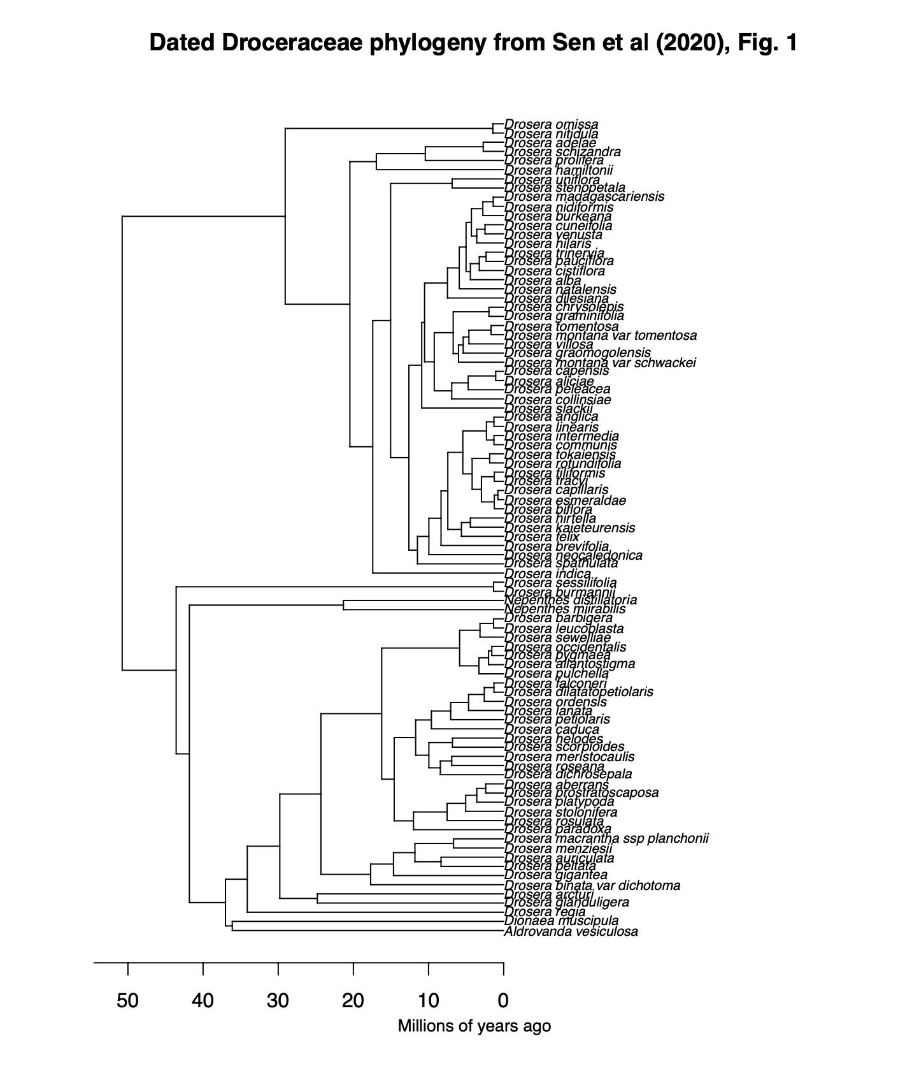

Appendix 1:

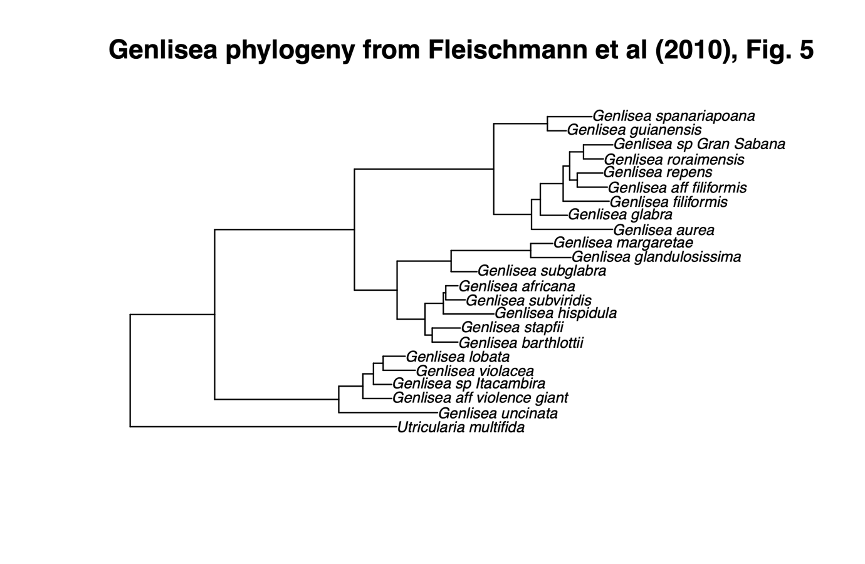

Appendix 2:

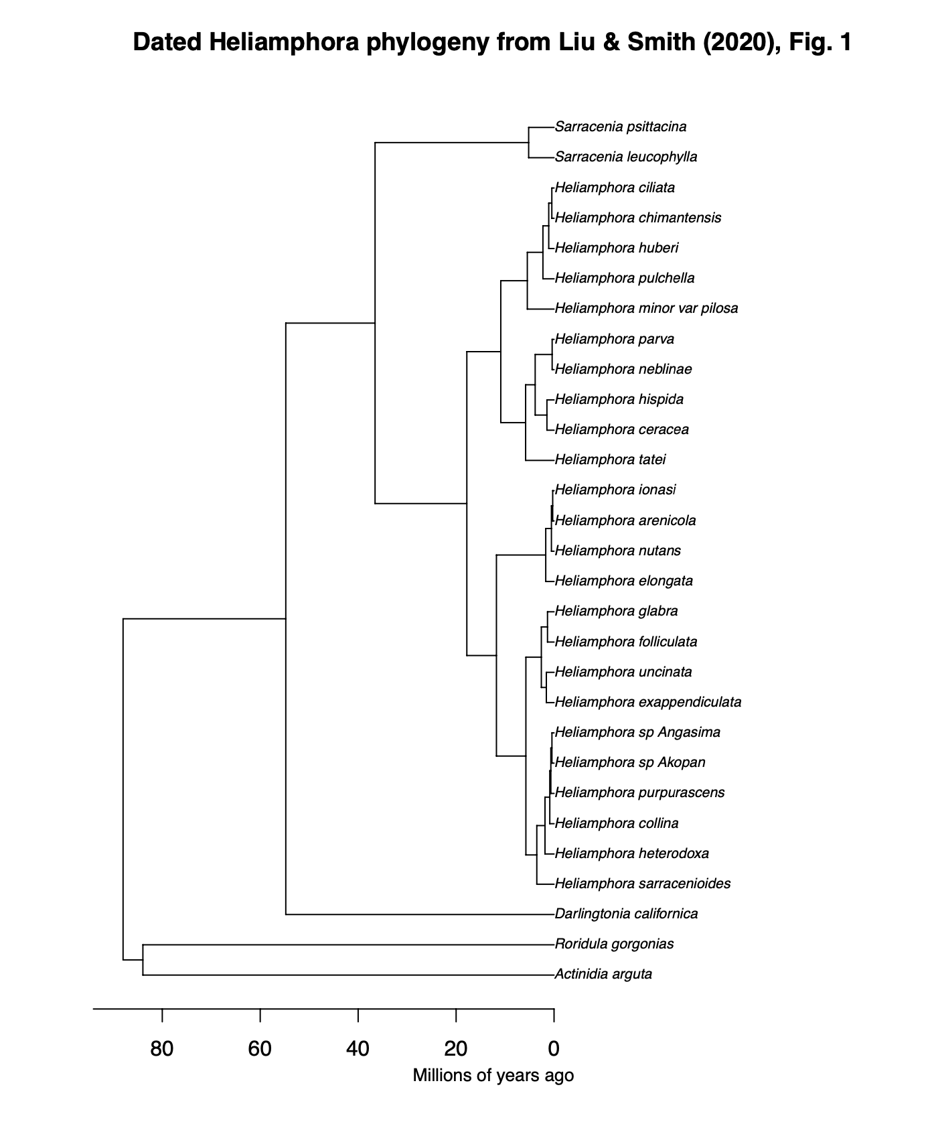Appendix 3:

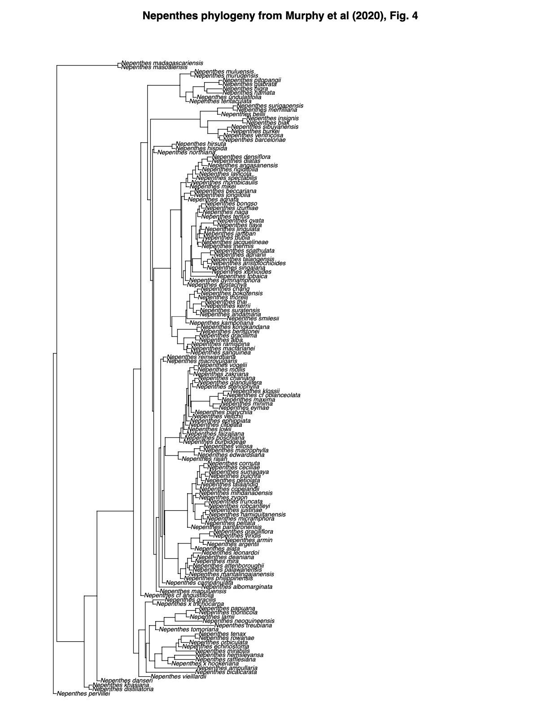

Apendix 4:

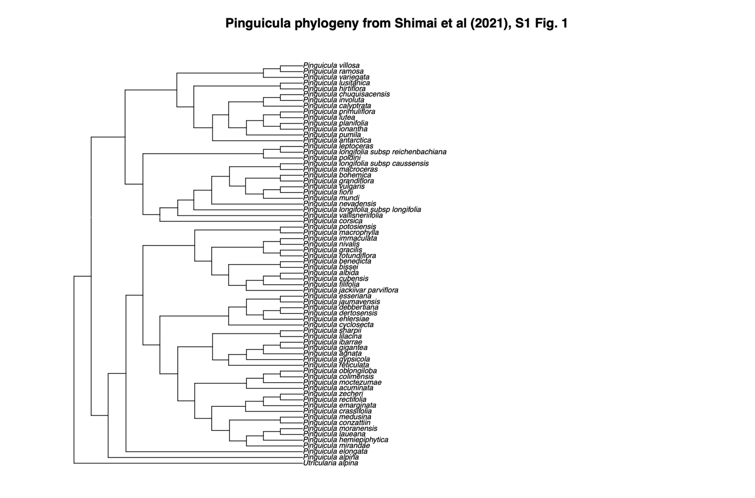

Appendix 5:

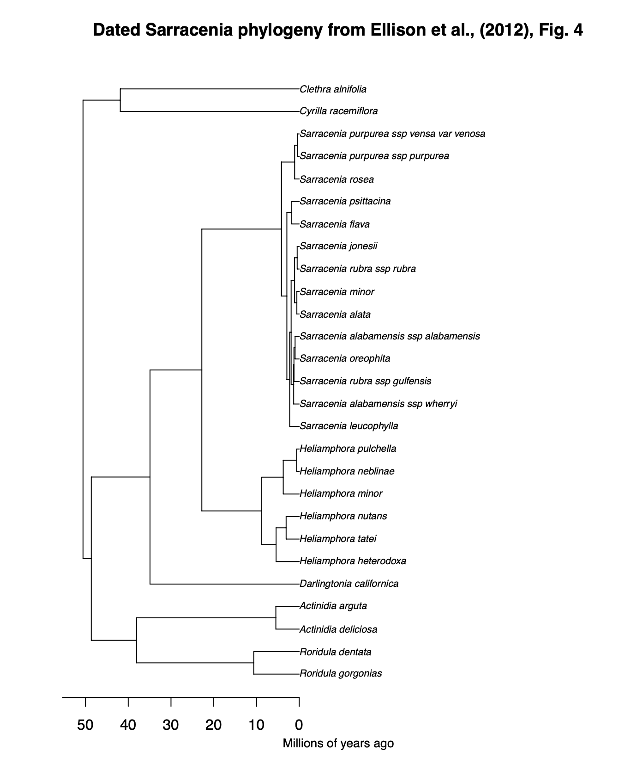

Appendix: 6:

Appendix 7:















